KWAME NKRUMAH UNIVERSITY OF SCIENCE AND TECHNOLOGY
COLLEGE OF SCIENCE
DEPARTMENT OF COMPUTER SCIENCE
INDIVIDUAL MINI PROJECT PROPOSAL
PROJECT TITLE:
Design and Implementation of a Digital Safety and Record Protection System for Online Abuse Victims Using Python and Machine Learning
Submitted by:

Programme: BSc. Computer Science
Year: Third Year
Academic Year: 2025/2026
Supervisor: PROF. FRIMPONG TWUM
Date: 18 June 2026

1. Project Topic / Title
Design and Implementation of a Digital Safety and Record Protection System for Online Abuse Victims Using Python and Machine Learning

2. Introduction
The rapid growth of the internet and digital communication technologies has transformed the way people interact, share information, and conduct daily activities. While these advancements have brought enormous benefits to society, they have also created new avenues for criminal behaviour, particularly in the form of online abuse, cyberbullying, harassment, and digital intimidation.
Online abuse refers to any form of harmful, threatening, or harassing behaviour carried out through digital platforms including social media, messaging applications, emails, and websites. Victims of online abuse, particularly women, young people, and students, often find themselves unable to seek justice due to the lack of proper tools to collect and preserve digital evidence in a legally admissible format.
In Ghana and across Africa, online harassment cases are rising at an alarming rate. However, law enforcement agencies frequently face challenges in prosecuting cybercriminals due to insufficient or improperly documented digital evidence. Victims who report cases often present screenshots and informal records that can easily be dismissed as tampered or unreliable.
This project proposes the design and implementation of a Digital Safety and Record Protection System that empowers online abuse victims to capture, preserve, and document digital evidence in a structured, tamper-proof, and legally sound manner using Python and Machine Learning technologies.

3. Problem Statement
Online abuse, cyberbullying, and digital harassment are escalating global problems that disproportionately affect vulnerable populations including women, students, and young people. Despite the severity of these offences, victims consistently struggle to obtain justice due to one fundamental problem: the absence of a reliable, structured, and legally admissible method for collecting and preserving digital evidence.
When victims approach law enforcement agencies, they typically present informal screenshots taken on their devices. These screenshots lack metadata verification, timestamp authentication, and integrity proof, making them easily dismissible as edited or fabricated. Cybercriminals exploit this gap by deleting their accounts and harmful content immediately after committing offences, leaving victims with no verifiable evidence and no legal recourse.
There is therefore a critical need for a dedicated system that enables victims to capture digital evidence immediately, preserve it with cryptographic integrity verification, analyze it intelligently using Machine Learning to confirm its abusive nature, and package it into a professional report that meets the standards required by law enforcement and courts of law.

4. Aim of Project
The aim of this project is to design and implement a web-based Digital Safety and Record Protection System that enables online abuse victims to securely collect, preserve, and document digital evidence of harassment and abuse, using Python and Machine Learning to ensure the integrity and reliability of the evidence for legal purposes.

5. Specific Objectives of the Project
The following specific objectives will guide the development of the system:
- To study and identify the key challenges faced by online abuse victims in collecting and presenting digital evidence to law enforcement.
- To design a web-based system architecture that allows victims to submit and store digital evidence of online abuse securely.
- To implement a cryptographic hashing and encryption mechanism using Python to generate unique digital fingerprints for all submitted evidence, ensuring tamper-proof integrity.
- To integrate a Machine Learning text classification model to automatically detect and flag abusive, threatening, and harassing content within submitted evidence.
- To develop an automated report generation module that packages collected evidence into a professional, structured, and legally presentable format for law enforcement and legal proceedings.

6. Project Scope
This project covers the design and implementation of a web-based application, accessible through any standard browser on a laptop or mobile device, that allows online abuse victims to submit digital evidence such as text messages, URLs, and records of harassment. Upon submission, the system automatically timestamps and applies cryptographic hashing to each piece of evidence to guarantee its integrity, while a Machine Learning text classification module analyses the content to detect and flag abusive or threatening language. All evidence is securely stored in a database protected by user authentication, and the system concludes the process by automatically generating a downloadable, professionally formatted evidence report suitable for submission to law enforcement.
The project is scoped as a functional prototype developed and demonstrated within an academic environment using sample and simulated data. As such, it does not extend to live public deployment, automated scraping of social media platforms, development of a dedicated mobile application, or direct integration with external law enforcement databases, as these fall outside the practical timeline and resource boundaries of a mini project.

7. Motivation of Project
The motivation for this project stems from the growing prevalence of online abuse in Ghanaian society and the evident gap in tools available to victims who seek justice. Stories of individuals, particularly young women and students, being harassed, blackmailed, and cyberbullied online, only to be told by authorities that their evidence is insufficient, highlight a deeply troubling systemic failure.
The increasing use of social media platforms, instant messaging applications, and online forums in Ghana has created fertile ground for digital abuse. Yet the legal and technological infrastructure to support victims lags significantly behind. This project is motivated by the desire to bridge this gap using accessible, affordable, and practical technology.
Furthermore, as a student of Computer Science with an interest in cybersecurity and digital forensics, this project presents an opportunity to apply academic knowledge to solve a real-world problem that directly affects vulnerable members of society, while simultaneously developing practical skills in Python programming, Machine Learning, and forensic techniques.

8. Justification of Project
This project is justified on the following grounds:
- Social Relevance: Online abuse affects millions of people globally and thousands in Ghana. A tool that empowers victims to collect proper evidence directly addresses a pressing social need.
- Legal Significance: The system produces forensically sound evidence that meets legal standards, improving the chances of successful prosecution of cybercriminals under Ghana's Electronic Communications Act and Criminal Offences Act.
- Technical Innovation: The combination of cryptographic hashing and Machine Learning for evidence protection and analysis represents a novel approach to victim support in the Ghanaian cybersecurity landscape.
- Academic Contribution: The project contributes to the growing body of knowledge in cybersecurity and digital forensics within the Department of Computer Science at KNUST.

9. Project Methodology

9.1 Project Approach
This project will follow the Agile Development Methodology, which allows for iterative development, continuous testing, and progressive feature enhancement throughout the project lifecycle. The development will proceed through the following phases:
- Requirements Analysis: Study the problem domain, identify user needs, and define functional and non-functional requirements.
- System Design: Design the system architecture, database schema, user interface wireframes, and data flow diagrams.
- Implementation: Develop the system module by module: evidence capture, hashing, ML analysis, database storage, and report generation.
- Testing and Validation: Conduct unit testing, integration testing, and user acceptance testing to validate system functionality.
- Documentation and Deployment: Prepare full technical documentation and deploy the prototype for demonstration.

9.2 Development Tools
The following tools and technologies will be used in the development of the system:
- Programming Language: Python 3.x, for backend processing, hashing, ML, and report generation.
- Web Framework: FastAPI, for building the backend REST API.
- Machine Learning Library: Scikit-learn and NLTK, for text classification and harassment detection.
- Security Library: Python Cryptography and Hashlib, for encryption and SHA-256 hash generation.
- Database: SQLAlchemy with SQLite/MySQL, for secure storage of evidence records.
- Report Generation: FPDF, for generating professional evidence reports.
- Frontend: HTML5, CSS3 and JavaScript, for a clean and responsive user interface.
- Development Environment: Visual Studio Code, with a Python virtual environment.
- Version Control: Git and GitHub, for source code management and version tracking.

10. Project Deliverables
Upon completion of this project, the following deliverables will be produced:
- A fully functional web-based Digital Safety and Record Protection System prototype that allows victims to submit, preserve, and manage digital evidence of online abuse.
- A Machine Learning powered text classification module capable of automatically detecting and flagging abusive, threatening, and harassing content.
- A cryptographic evidence integrity module that generates secure hash values for all submitted evidence, ensuring tamper-proof protection.
- An automated report generation module that packages all evidence into a professional, structured, and legally presentable document.
- A secure database for the storage and management of all evidence records submitted by victims.
- A comprehensive project report documenting the design, implementation, testing, and evaluation of the system.
- A live demonstration of the working system presented to the project supervisor and assessment panel.

11. Project Plan

11.1 Action Plan
The project will be executed over a period of twelve (12) weeks. The table below outlines the key activities, their timelines, and expected outcomes.
S/N | Activity | Timeline | Expected Outcome
1 | Submit and finalize approved proposal | Week 1 | Approved proposal document
2 | Conduct literature review on digital forensics and online abuse | Week 1 - 2 | Literature review report
3 | Design system architecture, ER diagram and UI wireframes | Week 2 - 3 | System design document
4 | Set up development environment, database and authentication | Week 3 - 4 | Working dev environment
5 | Develop evidence capture and submission module | Week 4 - 6 | Functional capture module
6 | Implement cryptographic hashing and encryption | Week 5 - 6 | Tamper-proof evidence storage
7 | Develop and integrate Machine Learning detection module | Week 6 - 8 | Working ML classifier
8 | Build automated PDF evidence report generator | Week 7 - 8 | Sample generated reports
9 | Integrate frontend interface with backend API | Week 8 - 9 | Fully connected web application
10 | Conduct system testing and debugging | Week 9 - 11 | Test report and bug-free system
11 | Write final project documentation | Week 10 - 12 | Complete project report
12 | Prepare and deliver final presentation/demo | Week 12 | Successful project defence

11.2 Gantt Chart
The Gantt chart below illustrates the scheduling and duration of each activity across the twelve-week project timeline.
Task | W1 | W2 | W3 | W4 | W5 | W6 | W7 | W8 | W9 | W10 | W11 | W12
Proposal & Requirements
Literature Review
System Design
Database & Auth Setup
Evidence Capture Module
Hashing & Encryption
ML Detection Module
PDF Report Module
Frontend Integration
Testing & Debugging
Documentation
Final Presentation
Shaded blocks indicate the active week(s) for each activity.

11.3 Milestones
The following key milestones will be used to track and measure progress throughout the project:
Milestone | Description | Target Date
M1 | Proposal Approval | End of Week 1
M2 | Completion of System Design | End of Week 3
M3 | Core Backend Modules Completed (Capture, Hashing, Database) | End of Week 6
M4 | ML Detection Module Integrated | End of Week 8
M5 | Full System Integration (Frontend + Backend + Reports) | End of Week 9
M6 | Testing Completed and System Validated | End of Week 11
M7 | Final Report Submission and Project Defence | End of Week 12

12. References
Council of Europe. (2024). Mapping study on cyberviolence. Strasbourg: Council of Europe Publishing.
Ghana Police Service. (2023). Annual report on cybercrime trends in Ghana. Accra: Ghana Police Service, Cybercrime Unit.
Casey, E. (2011). Digital evidence and computer crime: Forensic science, computers, and the internet (3rd ed.). London: Academic Press.
Pedregosa, F., Varoquaux, G., Gramfort, A., Michel, V., Thirion, B., Grisel, O., et al. (2011). Scikit-learn: Machine learning in Python. Journal of Machine Learning Research, 12, 2825-2830.
National Institute of Standards and Technology. (2015). Secure hash standard (SHS) (FIPS PUB 180-4). Gaithersburg, MD: U.S. Department of Commerce.
Parliament of the Republic of Ghana. (2008). Electronic Communications Act, 2008 (Act 775). Accra: Government of Ghana.
Parliament of the Republic of Ghana. (1960). Criminal Offences Act, 1960 (Act 29, as amended). Accra: Government of Ghana.
Ramirez, A. R., & Garcia, F. M. (2022). Natural language processing approaches to online harassment detection: A systematic review. Computers in Human Behavior Reports, 6, 100192.
Sommerville, I. (2016). Software engineering (10th ed.). Boston: Pearson Education.
CHAPTER 2
REVIEW OF RELATED SYSTEMS
INTRODUCTION
This chapter reviews existing systems related to digital evidence collection, online abuse detection, and victim protection platforms. Current technologies, methods, and tools used in similar systems are examined to identify their strengths, limitations, and gaps. The insights gathered from this review provide a valuable foundation that will inform the design and development of the proposed DigiSafe system.
OVERVIEW OF EXISTING SYSTEMS
The rapid growth of internet connectivity and digital communication platforms has given rise to an alarming increase in online abuse, cyberbullying, and digital harassment. Victims of these offences consistently face a significant challenge when seeking justice: the inability to collect, preserve, and present digital evidence in a format that is forensically sound and legally admissible (Casey, 2011).
In response to these challenges, various organisations, technology companies, and academic researchers have developed systems and tools aimed at supporting victims of online abuse, moderating harmful content, and preserving digital records. These solutions range from image-based abuse prevention platforms to machine learning powered content analysis tools and victim support networks (Jigsaw, 2017; Internet Watch Foundation, 2021).
While these systems represent meaningful progress in addressing online abuse, each addresses only a specific dimension of the problem. None provides a comprehensive solution that integrates evidence collection, cryptographic integrity verification, intelligent content analysis, and legally formatted documentation in a single platform. The following sections critically examine three of the most relevant existing systems and evaluate their features and limitations in the context of the proposed DigiSafe system (Reyns et al., 2011; Wulczyn et al., 2017).
REVIEW OF EXISTING SYSTEMS
System 1: StopNCII (Stop Non-Consensual Intimate Image Abuse)
StopNCII is a free online platform developed by the Revenge Porn Helpline in partnership with the Internet Watch Foundation and Meta Platforms Inc., officially launched in 2021. The platform is designed to help victims of image-based abuse prevent the non-consensual sharing of their intimate images across major social media and online platforms. StopNCII operates by allowing victims to generate a unique digital hash of their intimate image directly on their own device, without the image ever being uploaded or stored on any external server. This hash is then shared with partner platforms, which use it to proactively detect and block the distribution of that specific image across their networks (Internet Watch Foundation, 2021). The system currently partners with Facebook, Instagram, TikTok, Pornhub, and OnlyFans, among others, providing broad coverage for victims across multiple platforms (Revenge Porn Helpline, 2022).
Features of StopNCII:
- Privacy-preserving perceptual hashing of intimate images directly on the victim's device
- Cross-platform hash distribution to multiple partner platforms simultaneously
- Image blocking and proactive detection before content spreads widely
- Emotional support resources and referrals for survivors

Good Features of StopNCII:
- Privacy-Preserving Technology: The system generates a hash fingerprint of images directly on the victim's device without ever transmitting the actual image to any external server, significantly reducing the risk of secondary privacy violations (Internet Watch Foundation, 2021).
- Proactive Prevention: Unlike most reporting tools that respond to abuse after it has already occurred, StopNCII proactively prevents the initial distribution of non-consensual images by blocking matching content before it reaches wider audiences.
- Cross-Platform Coverage: Hash values are simultaneously distributed to multiple partner platforms, enabling coordinated detection and removal across several major social media networks at once (Revenge Porn Helpline, 2022).
- Accessibility: The platform is entirely free to use and requires no technical expertise, making it accessible to a wide range of users regardless of their digital literacy level.

Limitations of StopNCII:
- Restricted to Image-Based Abuse Only: StopNCII exclusively handles non-consensual intimate images and does not address other equally prevalent forms of online abuse such as threatening text messages, verbal harassment, blackmail, or cyberstalking, significantly limiting its scope of protection (Internet Watch Foundation, 2021).
- No Evidence Collection or Documentation: The system focuses entirely on prevention and removal rather than evidence collection. It does not provide victims with a forensically sound record of the abuse or generate documentation suitable for submission to law enforcement authorities (Casey, 2011).
- Dependence on Platform Participation: The effectiveness of StopNCII is entirely dependent on the willingness of online platforms to participate in the system. Content can continue to circulate freely on non-participating websites and platforms, leaving significant gaps in protection (Revenge Porn Helpline, 2022).
- No Legal Documentation Support: StopNCII does not produce evidence packages or reports that can be used in criminal proceedings, leaving victims without adequate support for pursuing legal action against perpetrators.

System 2: Google Perspective API
The Perspective API is a machine learning powered tool developed by Jigsaw, a technology incubator within Google, in collaboration with the New York Times and The Economist. First released publicly in 2017, Perspective API uses deep learning models trained on large datasets of human-labelled comments to automatically assess the toxicity and harmfulness of online text content (Jigsaw, 2017). The system assigns a toxicity score between zero and one to any submitted text, with higher scores indicating a greater likelihood that the content would be perceived as harmful, rude, or threatening. Perspective API supports analysis across multiple dimensions of harmful content including toxicity, severe toxicity, identity attacks, insults, profanity, and threats, and is available freely to developers who wish to integrate it into their own applications (Wulczyn et al., 2017).
Features of Perspective API:
- Real-time machine learning analysis of submitted text content
- Multi-dimensional toxicity scoring across several categories of harmful language
- Support for multiple languages including English, Spanish, French, and German
- Free API access for developers via Google Cloud

Good Features of Perspective API:
- Advanced Machine Learning Models: Perspective API is powered by convolutional neural networks trained on millions of labelled comments, enabling it to detect subtle and nuanced forms of harmful language with high accuracy across diverse contexts (Wulczyn et al., 2017).
- Multi-Dimensional Scoring: Unlike simple keyword-based filters, Perspective API evaluates text across multiple harm dimensions simultaneously, providing a comprehensive and nuanced assessment of potentially harmful content (Jigsaw, 2017).
- Real-Time Analysis: The API processes text and returns scores in real time, making it highly suitable for live content moderation applications where immediate detection and response are critical.
- Freely Available: The API is accessible free of charge to developers through Google Cloud, enabling broad integration across a wide range of third-party applications and research projects.

Limitations of Perspective API:
- No Evidence Collection or Preservation: Perspective API is purely an analysis tool and does not collect, store, timestamp, or preserve evidence in any form. It cannot produce forensically sound records admissible in legal proceedings, significantly limiting its utility for abuse victims seeking justice (Casey, 2011).
- Known Bias in Predictions: Research has demonstrated that Perspective API exhibits measurable bias against comments referencing certain demographic groups, sometimes incorrectly flagging non-harmful content as toxic, which reduces the system's reliability in diverse contexts such as Ghana (Dixon et al., 2018).
- Not Designed for Victim Use: The API is a developer tool designed for technical integration into larger platforms. It is not designed to be used directly by victims of online abuse and includes no victim support features, report generation, or legal guidance (Jigsaw, 2017).
- No Cryptographic Integrity Verification: The system incorporates no hashing or encryption mechanisms to verify the integrity of analysed content, making it unsuitable as a standalone forensic tool (National Institute of Standards and Technology, 2015).

System 3: The Cybersmile Foundation Digital Support Platform
The Cybersmile Foundation is an international non-profit organisation established in 2010 that operates a comprehensive digital support platform for victims of cyberbullying and online abuse. The platform provides a range of services including an AI-powered chatbot called Cybersmile Assistant, a Total Access Support System (TASS) for connecting victims with professional support, educational resources, and a global helpline accessible to users in multiple countries (Cybersmile Foundation, 2020). The Cybersmile Assistant uses natural language processing to engage with users, assess their situation, and direct them to appropriate resources. The platform has been recognised by major technology companies including Microsoft, Apple, and Google for its contribution to digital well-being, and its primary focus is on emotional support, education, and referral services rather than technical evidence management (Cybersmile Foundation, 2020).
Features of The Cybersmile Foundation Platform:
- AI-powered Cybersmile Assistant chatbot using natural language processing
- Total Access Support System connecting victims to professional counsellors and legal advisors
- Educational resources for individuals, schools, and organisations on online safety
- Global helpline accessible across multiple countries and languages

Good Features of The Cybersmile Foundation Platform:
- AI-Powered Conversational Support: The Cybersmile Assistant uses natural language processing to provide immediate, personalised guidance to victims, helping them navigate available support options in a conversational and accessible format (Cybersmile Foundation, 2020).
- Comprehensive Support Ecosystem: The platform connects victims with a wide network of professional counsellors, legal advisors, and law enforcement contacts, providing holistic support that addresses both the emotional and practical dimensions of online abuse.
- Global Reach: The Cybersmile Foundation operates across multiple countries and provides support in several languages, making it one of the most internationally accessible victim support platforms currently available.
- Educational Impact: The platform provides extensive educational materials for individuals, schools, and organisations on recognising and responding to cyberbullying, contributing to broader digital literacy and online safety awareness.

Limitations of The Cybersmile Foundation Platform:
- No Technical Evidence Collection: The platform is focused entirely on emotional support and referral services. It does not provide any technical mechanism for collecting, preserving, or documenting digital evidence of abuse in a legally admissible format (Cybersmile Foundation, 2020).
- No Forensic Capabilities: The system does not implement any cryptographic hashing, metadata extraction, or integrity verification mechanisms that would make collected evidence suitable for formal legal proceedings (Casey, 2011).
- Dependent on External Partner Availability: The effectiveness of the platform's support network depends heavily on the availability and responsiveness of partner organisations in each country. In regions with limited partner coverage such as Ghana, the quality of support available to victims may be significantly reduced.
- No Report Generation: The platform does not generate any formal documentation or evidence reports that victims can present directly to law enforcement agencies. While it provides guidance on reporting, the actual preparation of evidence packages remains entirely the victim's responsibility.

COMPARATIVE SYSTEM ANALYSIS TABLE
Criteria | StopNCII | Google Perspective API | Cybersmile Foundation | Proposed DigiSafe System
Target Users | Victims of image-based abuse | Developers and platform moderators | Cyberbullying victims globally | Online abuse victims in Ghana and beyond
Evidence Collection | Not available | Not available | Not available | Full evidence capture and storage
Content Analysis (ML/AI) | Not available | Advanced ML toxicity scoring | Basic AI chatbot support | ML-based harassment and threat detection
Cryptographic Hashing | Perceptual hashing for images only | Not available | Not available | SHA-256 hash for all evidence types
Report Generation | Not available | Not available | Not available | Automated professional PDF report
Victim-Facing Interface | Yes — simple web form | No — developer API only | Yes — chatbot interface | Yes — full web application
Legal Documentation Support | Not available | Not available | Not available | Fully formatted for law enforcement
Handles Text-Based Abuse | No — images only | Yes — text analysis | Yes — chat support | Yes — text and URL evidence
Free to Use | Yes | Yes (limited) | Yes | Yes — prototype

JUSTIFICATION FOR THE PROPOSED SYSTEM
The review of the three existing systems above reveals that while significant efforts have been made to address online abuse through technology, each solution addresses only a limited dimension of the broader problem. StopNCII focuses on preventing the spread of non-consensual images but does not address textual harassment or produce legally usable evidence. Perspective API provides powerful machine learning analysis of harmful text but is a developer tool with no victim-facing features, no evidence preservation, and no forensic capabilities. The Cybersmile Foundation platform excels at emotional support and victim referral but provides no technical tools for evidence collection or legal documentation (Casey, 2011; Jigsaw, 2017; Cybersmile Foundation, 2020).
Critically, none of the reviewed systems integrates all three essential capabilities that a victim requires to pursue legal action: forensically sound evidence collection, cryptographic integrity verification, and professionally formatted documentation for law enforcement. This gap is precisely what the proposed DigiSafe system is designed to address.
By combining Machine Learning-based content analysis, SHA-256 cryptographic hashing for evidence integrity, secure database storage with user authentication, and automated PDF report generation in a single accessible web application, DigiSafe offers a comprehensive and uniquely integrated solution that goes beyond what any individual existing system currently provides (National Institute of Standards and Technology, 2015; Wulczyn et al., 2017). This positions the proposed system as a meaningful and original contribution to the field of digital victim protection and cybercrime evidence management in Ghana and beyond.
CONCEPTUAL DESIGN
The proposed DigiSafe system is structured to provide online abuse victims with a comprehensive, easy-to-use web-based platform for capturing, protecting, analysing, and documenting digital evidence of harassment. The system consists of four integrated modules working together to deliver a complete evidence management solution.
How It Works:
Evidence Capture and Submission Module:
- Victims access the system through any standard web browser on a laptop or mobile device.
- A secure submission form allows victims to input text-based evidence such as threatening messages, harassment content, and URLs of abusive online posts.
- Automatic timestamping records the exact date and time of each evidence submission to establish a clear timeline of abuse.

Cryptographic Integrity Module:
- Upon submission, the system automatically generates a SHA-256 cryptographic hash value for each piece of evidence.
- This hash serves as a unique digital fingerprint that proves the evidence has not been altered or tampered with after capture.
- All evidence and corresponding hash values are securely stored in an encrypted database protected by role-based user authentication.

Machine Learning Detection Module:
- Submitted text evidence is automatically analysed by a Machine Learning classifier trained to detect abusive, threatening, and harassing language patterns.
- The system assigns a threat level score and severity classification to each piece of evidence, helping victims and authorities understand the gravity of the abuse.
- Patterns of escalating harassment across multiple submissions are also identified and flagged.

Report Generation Module:
- The system automatically compiles all captured evidence, timestamps, hash values, and ML analysis results into a professionally formatted PDF evidence report.
- The report is structured to meet the documentation standards required by law enforcement agencies, making it directly usable for formal complaint submissions.
- Victims can download the report at any time from their secure account dashboard.

In summary, the proposed DigiSafe system ensures ease of use, data integrity, and legal admissibility of evidence for online abuse victims. It directly addresses the key gaps identified in existing systems, namely the absence of forensic evidence collection, cryptographic integrity verification, intelligent content analysis, and professionally formatted legal documentation, in a single, integrated, and accessible web application.
REFERENCES
Casey, E. (2011). Digital evidence and computer crime: Forensic science, computers, and the internet (3rd ed.). Academic Press.
Cybersmile Foundation. (2020). Total access support system and Cybersmile Assistant: Platform overview. Cybersmile Foundation. https://www.cybersmile.org
Dixon, L., Li, J., Sorensen, J., Thain, N., & Vasserman, L. (2018). Measuring and mitigating unintended bias in text classification. Proceedings of the 2018 AAAI/ACM Conference on AI, Ethics, and Society, 67–73. https://doi.org/10.1145/3278721.3278729
Internet Watch Foundation. (2021). StopNCII: Stop non-consensual intimate image abuse. Internet Watch Foundation. https://www.stopncii.org
Jigsaw. (2017). Perspective API: Using machine learning to reduce toxicity online. Google Jigsaw. https://perspectiveapi.com
National Institute of Standards and Technology. (2015). Secure hash standard (SHS) (FIPS PUB 180-4). U.S. Department of Commerce. https://doi.org/10.6028/NIST.FIPS.180-4
Revenge Porn Helpline. (2022). Annual report 2022: Supporting victims of image-based abuse. Revenge Porn Helpline. https://revengepornhelpline.org.uk
Reyns, B. W., Henson, B., & Fisher, B. S. (2011). Stalking in the twilight zone: Extent of cyberstalking victimisation and offending among college students. Deviant Behavior, 33(1), 1–25. https://doi.org/10.1080/01639625.2011.641087
Wulczyn, E., Thain, N., Dixon, L., Sorensen, J., Lee, L., & Vasserman, L. (2017). Ex machina: Personal attacks seen at scale. Proceedings of the 26th International Conference on World Wide Web, 1391–1399. https://doi.org/10.1145/3038912.3052591

CHAPTER 3
METHODOLOGY

3.1 Introduction
This chapter presents the methodology adopted for the design and implementation of the Digital Safety and Record Protection System (DigiSafe), a web-based platform designed to help online abuse victims collect, preserve, analyse, and document digital evidence in a legally admissible format. It outlines the system architecture, describes the design and function of each component, evaluates the type of software system to be developed, and specifies both the functional and non-functional requirements of the system.
The chapter further identifies the key stakeholders of the system, describes the requirement gathering process, and presents the Unified Modelling Language (UML) diagrams that model the system's behaviour and structure. Project design considerations — including user interface wireframes and database designs — are also presented. Finally, the software process model adopted and the developmental tools to be used are described in detail.

3.2 Architecture of the Proposed System
The proposed DigiSafe system adopts a layered (n-tier) client-server architecture consisting of four distinct layers: the Presentation Layer, the Application/API Layer, the Business Logic Layer, and the Data Layer. This architectural model was chosen because it provides a clear separation of concerns, making the system easier to develop, test, maintain, and scale.

Presentation Layer (Frontend): Built using HTML5, CSS3, and JavaScript, this layer renders the Victim Web Interface and the Admin/Law Enforcement Dashboard in any standard web browser. It is responsible for receiving victim input, displaying evidence records, and presenting analysis results.
Application/API Layer (FastAPI): This layer exposes a RESTful API built with Python's FastAPI framework. All HTTP requests from the Presentation Layer are routed through this layer, which handles authentication, input validation, and orchestrates calls to the Business Logic modules.
Business Logic Layer: This layer houses the five core processing modules: the Authentication Module, the Evidence Capture Module, the Security Module (SHA-256 hashing and AES encryption), the Machine Learning Detection Module, and the Report Generation Module.
Data Layer: Implemented with SQLAlchemy over a SQLite/MySQL relational database, this layer is responsible for the secure persistent storage of all user accounts, evidence records, hash values, classification results, alerts, and audit logs.

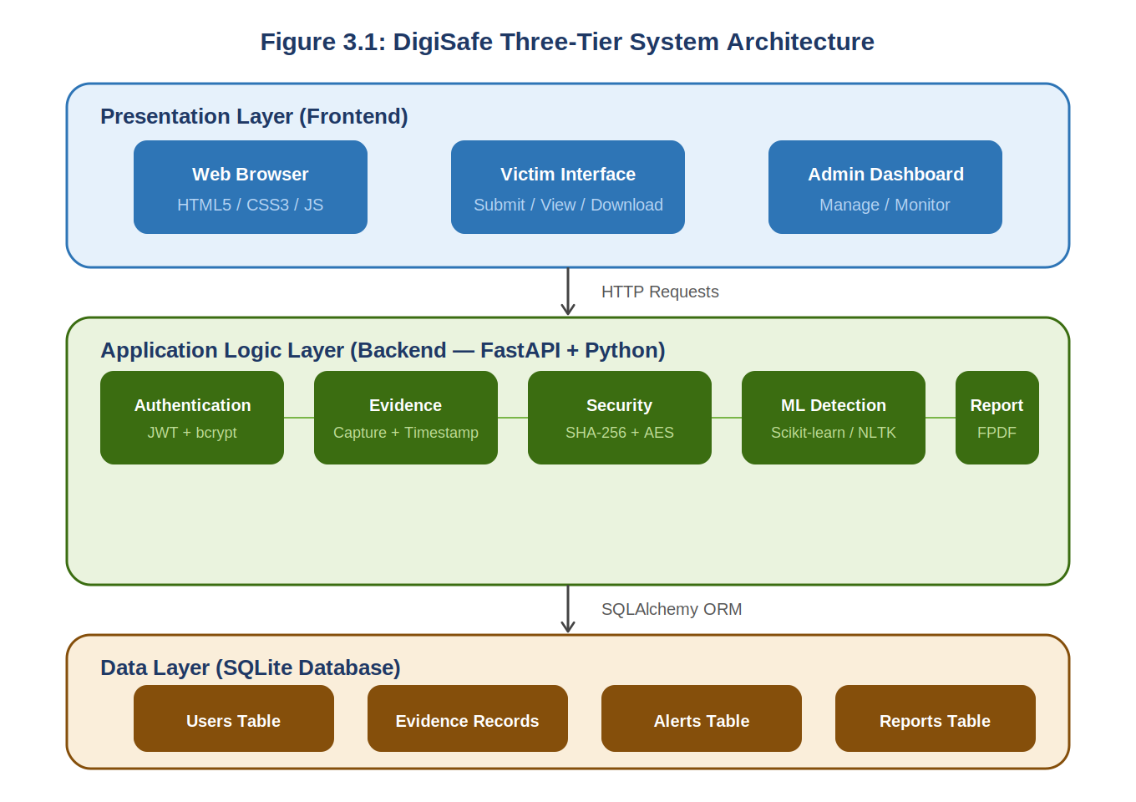
Figure 3.1: Layered Architecture of the Digital Safety and Record Protection System
As illustrated in Figure 3.1, requests from the Victim Web Interface and the Admin/Law Enforcement Dashboard are routed through the FastAPI REST API, processed by the relevant Business Logic modules, and persisted or retrieved from the database layer. This clear separation ensures each layer can be independently tested and maintained.

3.3 Component Design and Component Descriptions
The DigiSafe system comprises eight core components that work together to provide a comprehensive digital evidence management solution for online abuse victims. Each component is described in detail below.

3.3.1 Victim Web Interface
The Victim Web Interface is the Presentation Layer component through which victims interact with the system. Built with HTML5, CSS3, and JavaScript, it provides victims with a secure and emotionally sensitive interface to register, log in, submit evidence, view their evidence records, and download their PDF reports. All form inputs are validated on the client side before being submitted to the FastAPI backend.

3.3.2 Admin / Law Enforcement Dashboard
The Admin/Law Enforcement Dashboard is the second Presentation Layer component, providing System Administrators and Law Enforcement Officers with a secure interface to view all submitted evidence, review ML classification results, verify cryptographic integrity, flag high-severity cases, and access the system audit log. Access to this dashboard is restricted by role-based authentication.

3.3.3 Authentication and Access Control Module
This component manages user registration, login, session management, and role-based access control (Victim, Administrator, Law Enforcement Officer). Passwords are hashed using bcrypt before storage. Upon successful authentication, the module generates a JSON Web Token (JWT) that is included in every subsequent API request, ensuring that only authorised users can access protected endpoints.
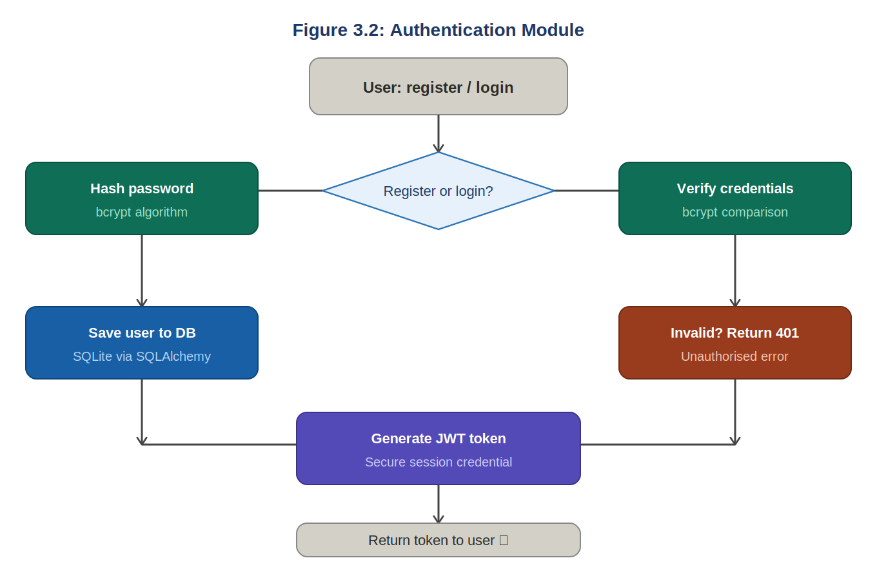
Figure 3.2a: Authentication Module Flow Diagram

3.3.4 Evidence Capture Module
The Evidence Capture Module provides victims with a structured interface to submit digital evidence in the form of text messages, harassment records, or URLs of abusive online posts. Upon submission, the module automatically records a timestamp and passes the evidence simultaneously to the Security Module for hashing and the Machine Learning Detection Module for content classification before persisting the complete record to the database.
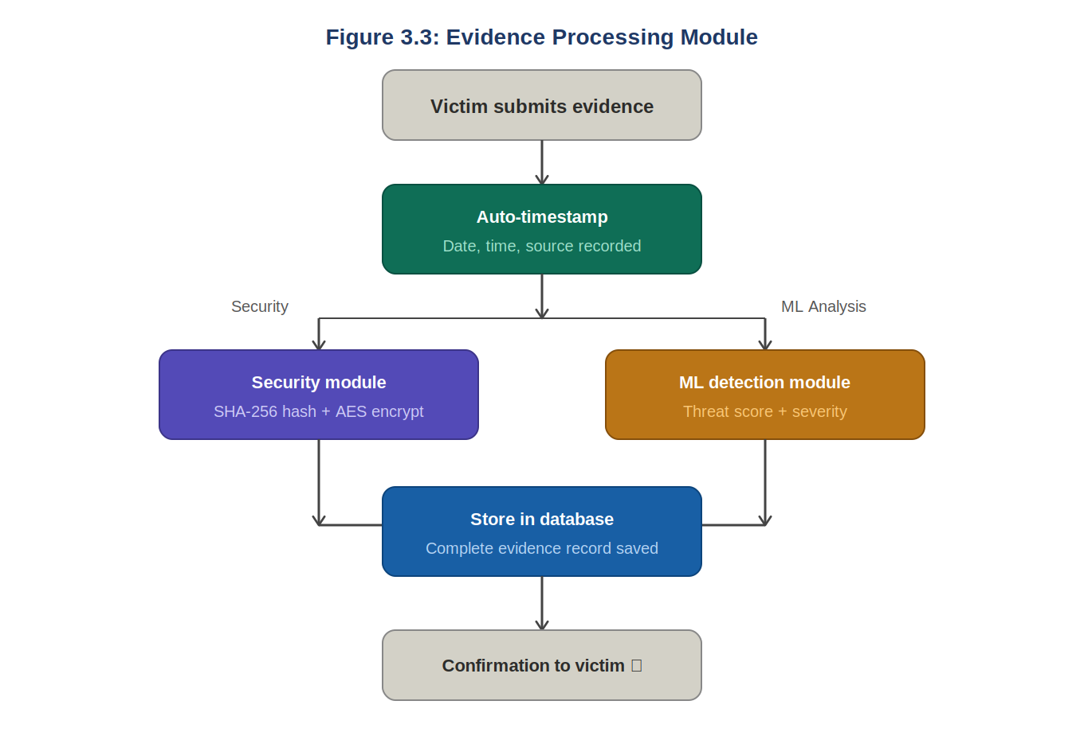
Figure 3.2b: Evidence Processing Module Flow Diagram

3.3.5 Cryptographic Hashing and Encryption Module
This module ensures the integrity and authenticity of every piece of submitted evidence. It applies the SHA-256 cryptographic hash function (via Python's hashlib library) to generate a unique 64-character hexadecimal digest — the digital fingerprint — for each evidence record. Additionally, it applies AES encryption to the evidence content before database storage, ensuring that data remains unreadable even if unauthorised database access is obtained.
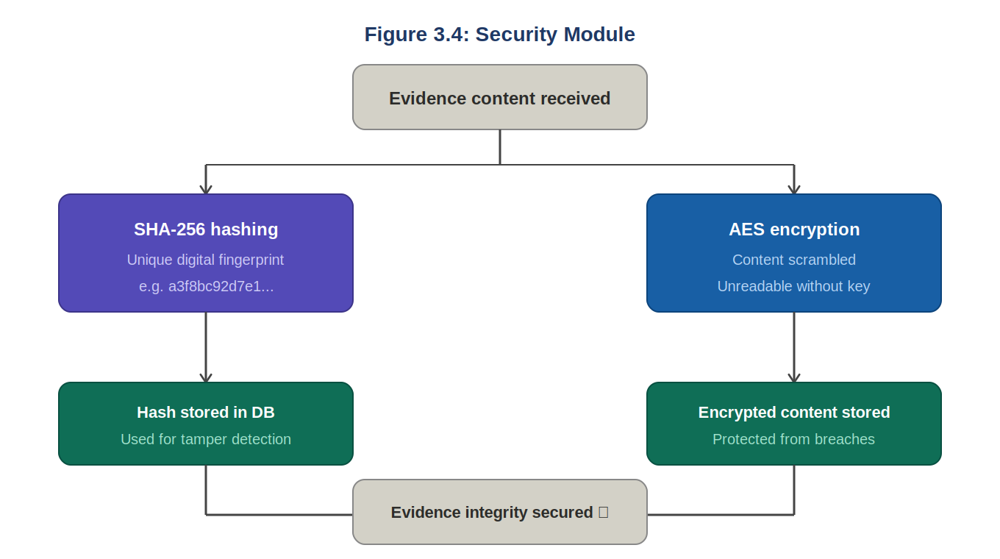
Figure 3.2c: Security Module (Hashing and Encryption) Diagram

3.3.6 Machine Learning Text Classification Module
This module uses a supervised text classification model built with Scikit-learn and pre-processed with the Natural Language Toolkit (NLTK) to automatically detect abusive, threatening, or harassing language in submitted evidence text. It assigns a composite threat level score (0.0–1.0) and a severity classification (None, Low, Medium, High, or Critical) to each evidence submission.
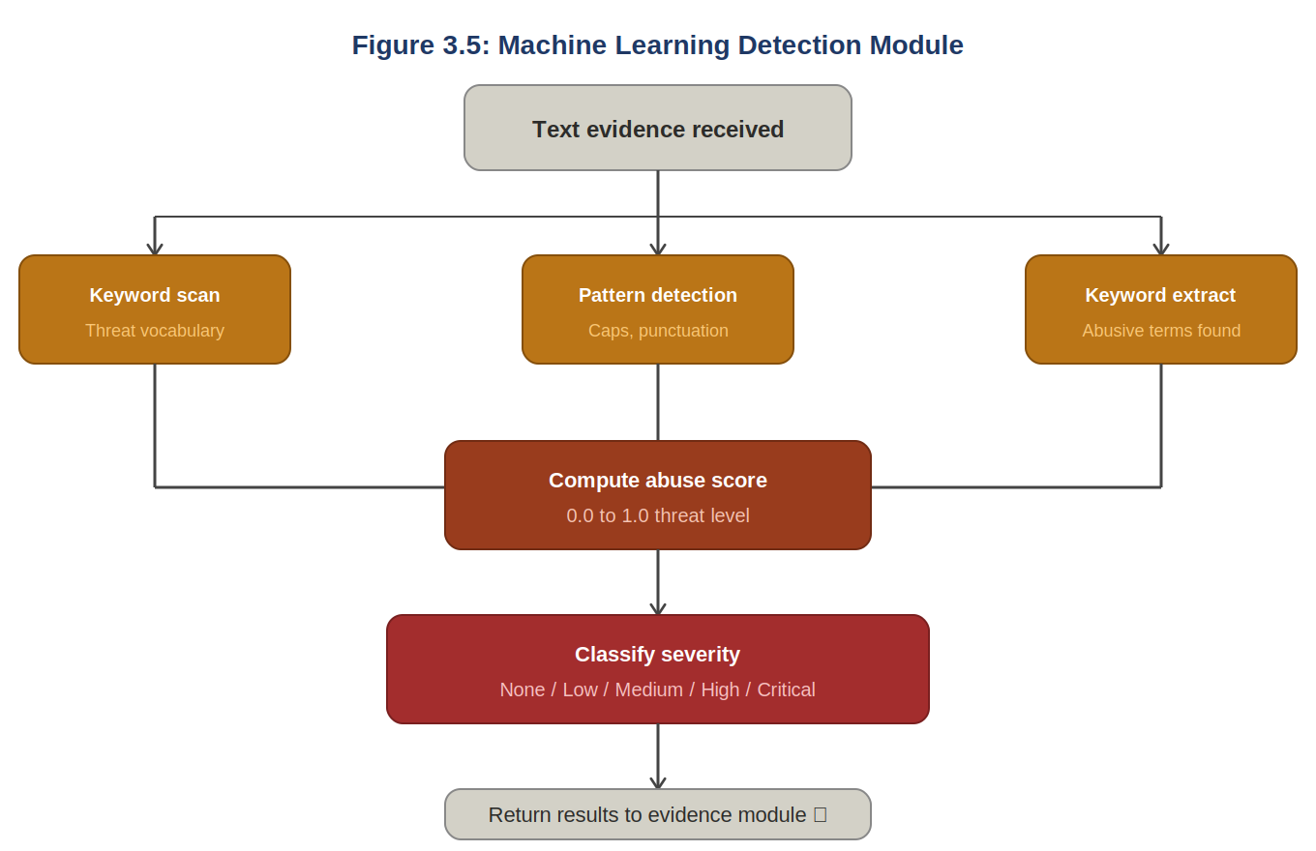
Figure 3.2d: Machine Learning Detection Module Diagram

3.3.7 Automated Report Generation Module
This module compiles verified evidence — including the original content, its cryptographic hash, timestamp, and ML classification result — into a structured, professional PDF document using the FPDF library. The generated report is formatted to meet the documentation standards required by law enforcement agencies, making it directly usable for formal complaint submissions.
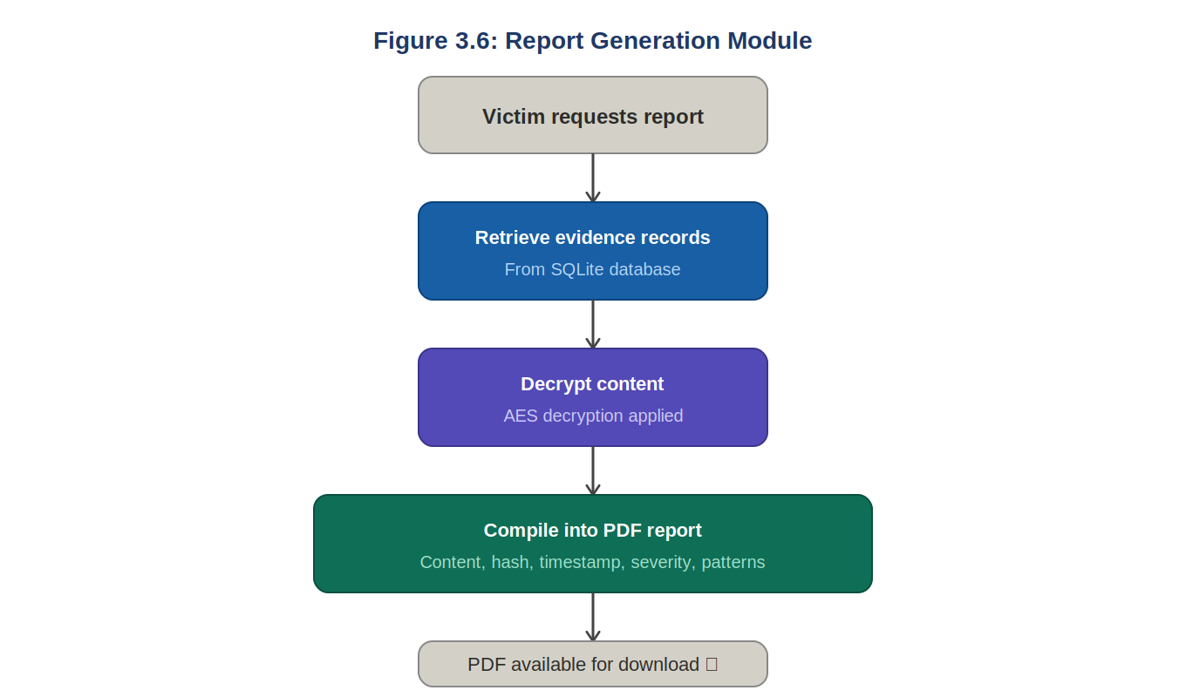
Figure 3.2e: Report Generation Module Diagram

3.3.8 Database Management Component
This component, implemented with SQLAlchemy over a SQLite/MySQL relational database, is responsible for the secure persistent storage of user accounts, evidence records, hash values, classification results, generated reports, alerts, and audit logs. Role-based access control is enforced at the database query level to ensure data confidentiality.

3.4 Evaluation and Analysis of the Type of Software System to be Developed
The proposed Digital Safety and Record Protection System is a web-based, multi-user, data-intensive application that combines transactional record-keeping, real-time machine learning inference, cryptographic processing, and document generation in a single integrated platform. This combination of capabilities places it firmly in the category of a Data-Intensive, Multi-Tier Web Application with AI-Powered Processing.
Architecturally, the system is a client-server, three-tier web application accessible through any standard browser, distinguishing it from desktop applications (which require installation) and mobile applications (which are platform-specific). The web-based approach was chosen because it maximises accessibility for victims who may be in distress and need to access the system from any available device without prior installation.

3.5 The Proposed System's Main Functionalities (Functional Requirements)
- The system shall allow victims to register and securely log into the platform.
- The system shall allow victims to submit digital evidence in the form of text, URLs, or message records.
- The system shall automatically timestamp every evidence submission at the point of capture.
- The system shall generate a SHA-256 cryptographic hash for every submitted piece of evidence to ensure tamper-proof integrity.
- The system shall automatically classify submitted text using a Machine Learning model to detect abusive, threatening, or harassing content.
- The system shall flag evidence classified as abusive for review by an administrator or law enforcement officer.
- The system shall allow victims to view the status and history of their submitted evidence.
- The system shall allow authorised administrators and law enforcement officers to view all evidence submissions and verify their cryptographic integrity.
- The system shall generate a structured, downloadable PDF evidence report for each case.
- The system shall maintain an audit log of significant user actions within the system.

3.6 Identification of Stakeholders of the System
Online Abuse Victims (Primary Users): Individuals who have experienced online harassment, cyberbullying, blackmail, or digital threats and need a reliable tool to capture and preserve evidence for legal purposes.
System Administrator: Responsible for managing user accounts, reviewing flagged evidence cases, monitoring system health, and maintaining the audit log.
Law Enforcement Officers: Authorised officers who access the system to review verified evidence records, confirm integrity through hash verification, and use generated reports in investigations.
Project Supervisor / Academic Assessor: Evaluates the technical design, implementation quality, and academic rigour of the project.
Future System Maintainer / Developer: Any developer responsible for maintaining, updating, or extending the system after initial deployment.

3.7 Requirement Gathering Process
Requirements for the system were gathered through the following methods:
- Literature Review: An examination of existing academic and industry literature on online abuse, digital forensics, and evidence preservation (as presented in Chapter 2) to understand the technical and legal standards for admissible digital evidence.
- Review of Related Systems: A comparative analysis of existing platforms to identify functional gaps that the proposed system must address.
- Informal Consultation: Discussions with peers and the project supervisor to understand realistic victim scenarios, legal evidentiary requirements, and technical feasibility constraints.
- Analysis of Legal Requirements: Review of Ghana's Electronic Communications Act, 2008 (Act 775) and Criminal Offences Act, 1960 (Act 29) to determine the documentation standards required for digital evidence to be admissible in legal proceedings.

3.8 Requirement Specification

3.8.1 Functional User Requirements
- As a victim, I want to create an account and securely log in so that my evidence records are private and protected.
- As a victim, I want to submit text messages, URLs, or descriptions of harassment so that I can document abuse as it happens.
- As a victim, I want to know that my submitted evidence cannot be altered, so that it remains credible if used in legal proceedings.
- As a victim, I want to download a professional report of my evidence so that I can present it to law enforcement.
- As an administrator, I want to view all flagged cases so that I can prioritise urgent reviews.
- As a law enforcement officer, I want to verify the integrity of submitted evidence so that I can confirm it has not been tampered with.

3.8.2 Functional System Requirements
- The system shall validate all mandatory fields before accepting an evidence submission.
- The system shall generate a unique SHA-256 hash immediately upon receipt of evidence content.
- The system shall invoke the ML classification model synchronously during the evidence submission workflow.
- The system shall persist evidence, hash, and classification records as a single atomic database transaction.
- The system shall restrict access to evidence records based on the authenticated user's role.
- The system shall log every create, read, update, and administrative action to the audit log.

3.9 UML Diagrams
This section presents the Use Case, Activity, and Sequence diagrams that model the behaviour of the proposed DigiSafe system.

3.9.1 Use Case Diagram — Victim (Front-End)
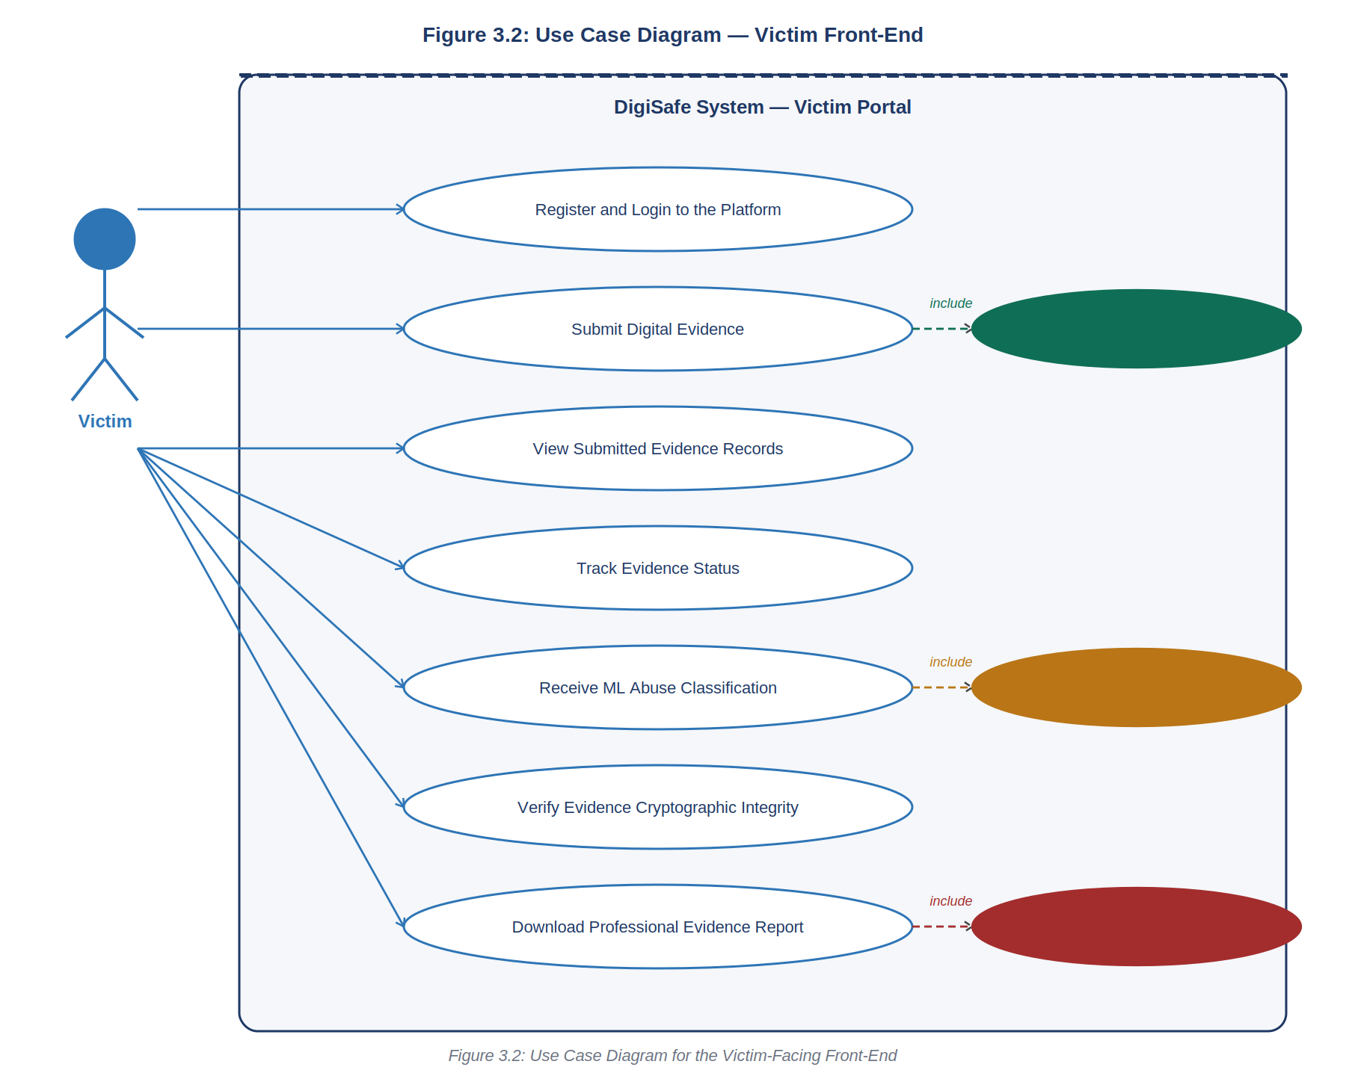
Figure 3.3: Use Case Diagram for the Victim-Facing Front-End

Use Case Description — Victim Front-End
Actor: Victim — A registered user of the platform who has experienced online abuse and wishes to document and preserve digital evidence.
Register and Login: The victim creates an account or logs in using their credentials. The system validates the input and returns a JWT access token upon success.
Submit Digital Evidence: The victim submits harassment content (text, URL, or file). The system captures it, generates a timestamp and SHA-256 hash, and runs ML classification. This use case includes Generate SHA-256 Hash.
View Submitted Evidence: The victim reviews a list of all evidence records they have previously submitted, along with their status and threat level.
Track Evidence Status: The victim monitors whether their evidence has been reviewed, flagged, or cleared by the system.
Receive ML Abuse Classification: The system automatically classifies submitted evidence and displays the result to the victim. This use case includes Run ML Classification.
Verify Evidence Integrity: The victim (or reviewer) can confirm that the stored hash matches the evidence content, proving it has not been tampered with.
Download Evidence Report: The victim requests a PDF report of their case. The system compiles the evidence, hash, and classification into a formatted document. This use case includes Generate PDF Report.

3.9.2 Use Case Diagram — Admin / Law Enforcement (Back-End)
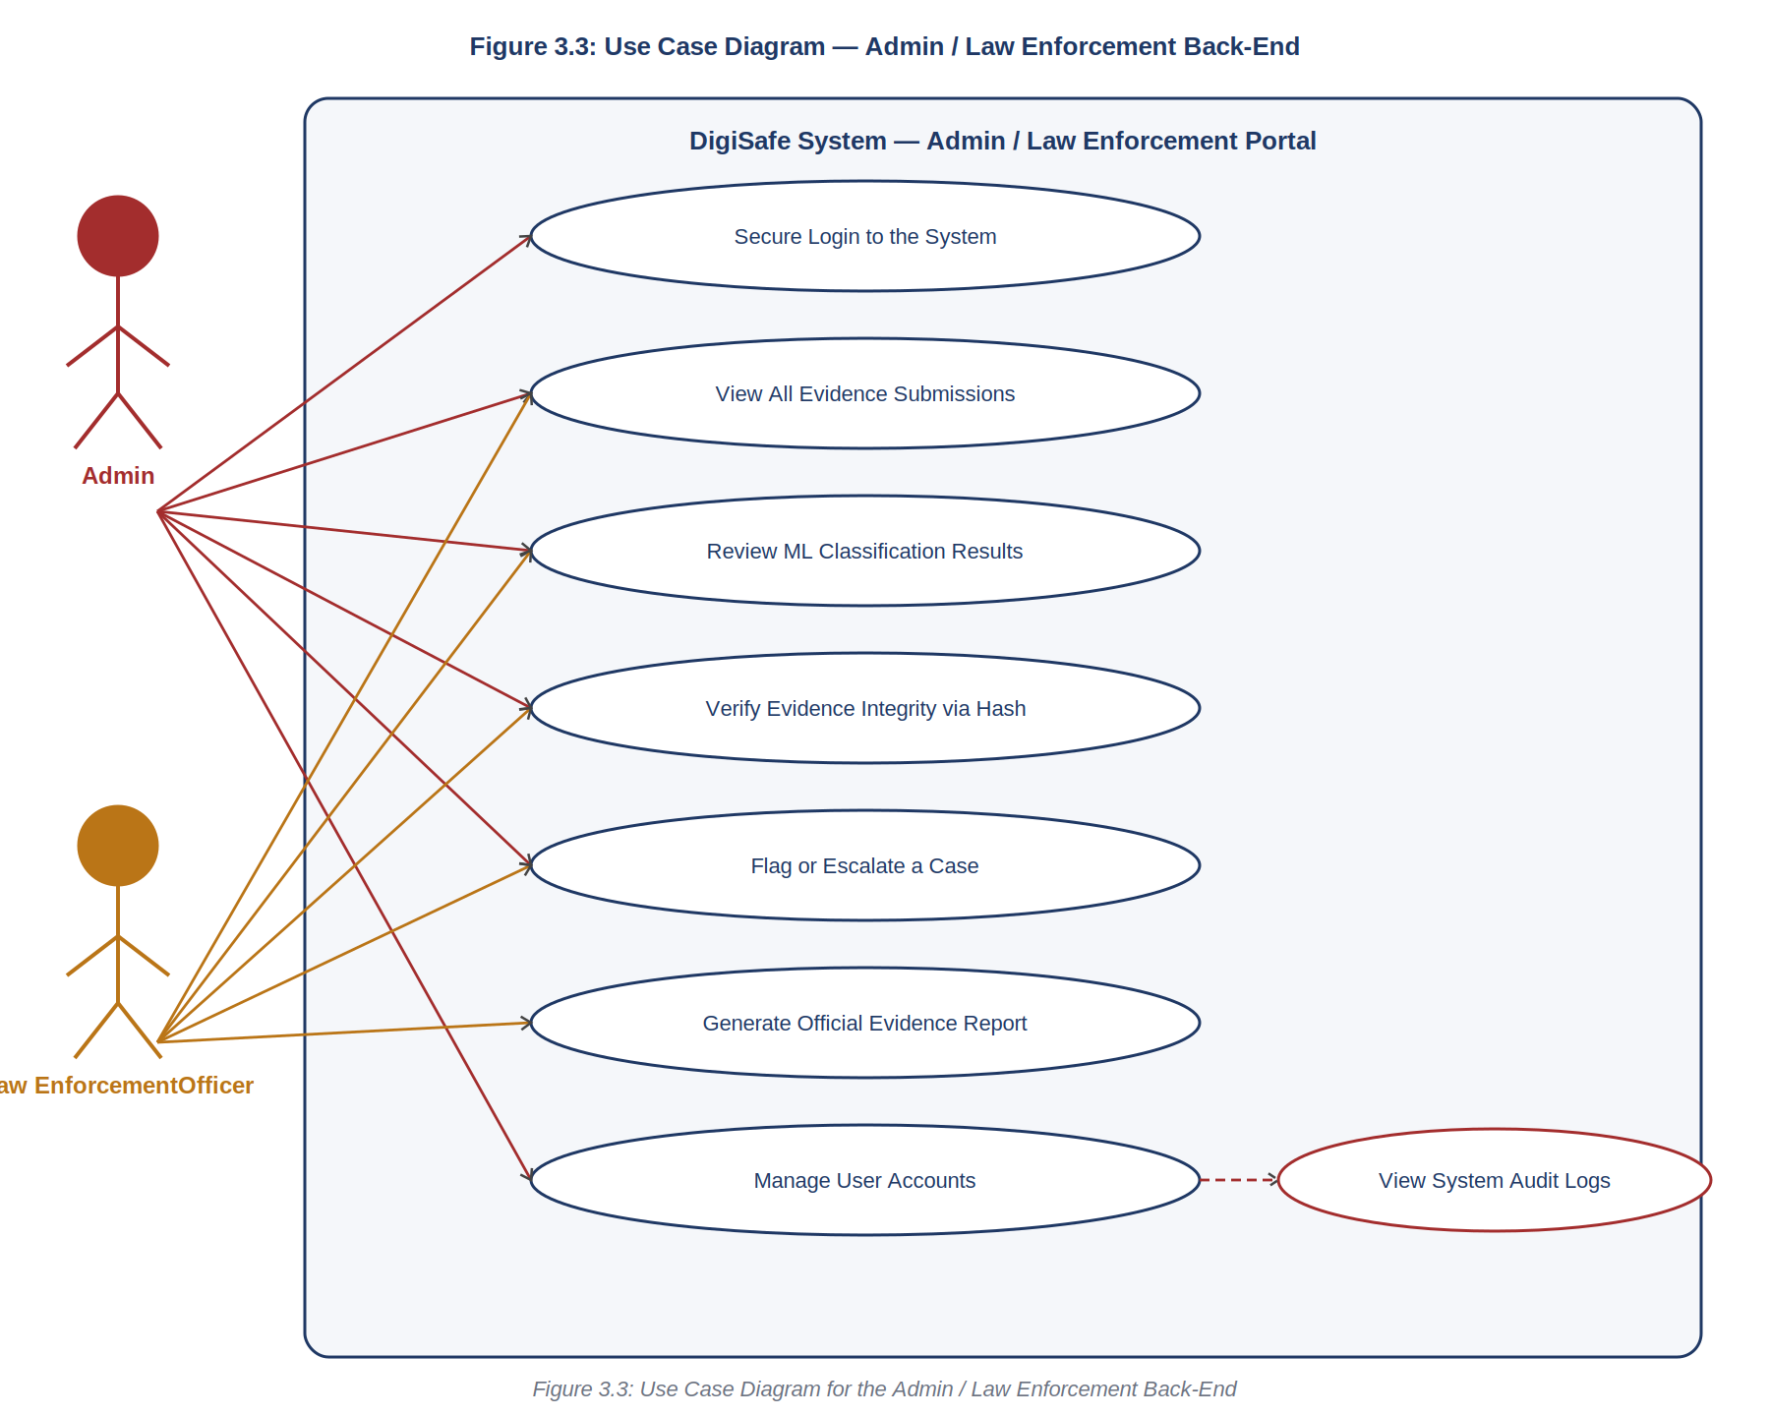
Figure 3.4: Use Case Diagram for the Admin / Law Enforcement Back-End

Use Case Description — Admin / Law Enforcement Back-End
Actors: System Administrator — manages platform users and oversees flagged content; Law Enforcement Officer — reviews verified evidence for investigation purposes.
Secure Login: Both actors authenticate using their credentials and role selection. The system returns a JWT token granting role-appropriate access.
View All Evidence Submissions: Both actors can browse all evidence records submitted by victims, filtered by date, status, or severity.
Review ML Classification Results: Both actors review the ML-generated threat level and severity classification for each evidence record.
Verify Evidence Integrity: Both actors can re-compute the SHA-256 hash and compare it against the stored value to confirm the evidence has not been altered.
Flag or Escalate a Case: Both actors can flag high-severity evidence for escalation or formal investigation.
Generate Official Evidence Report: Both actors can generate and download a formatted PDF report of any evidence record for use in investigations or proceedings.
Manage User Accounts (Admin only): The Administrator can create, suspend, or delete user accounts and assign roles.
View System Audit Logs (Admin only): The Administrator reviews the chronological log of all significant system actions for accountability and oversight.

3.9.3 Activity Diagram — Evidence Submission Process
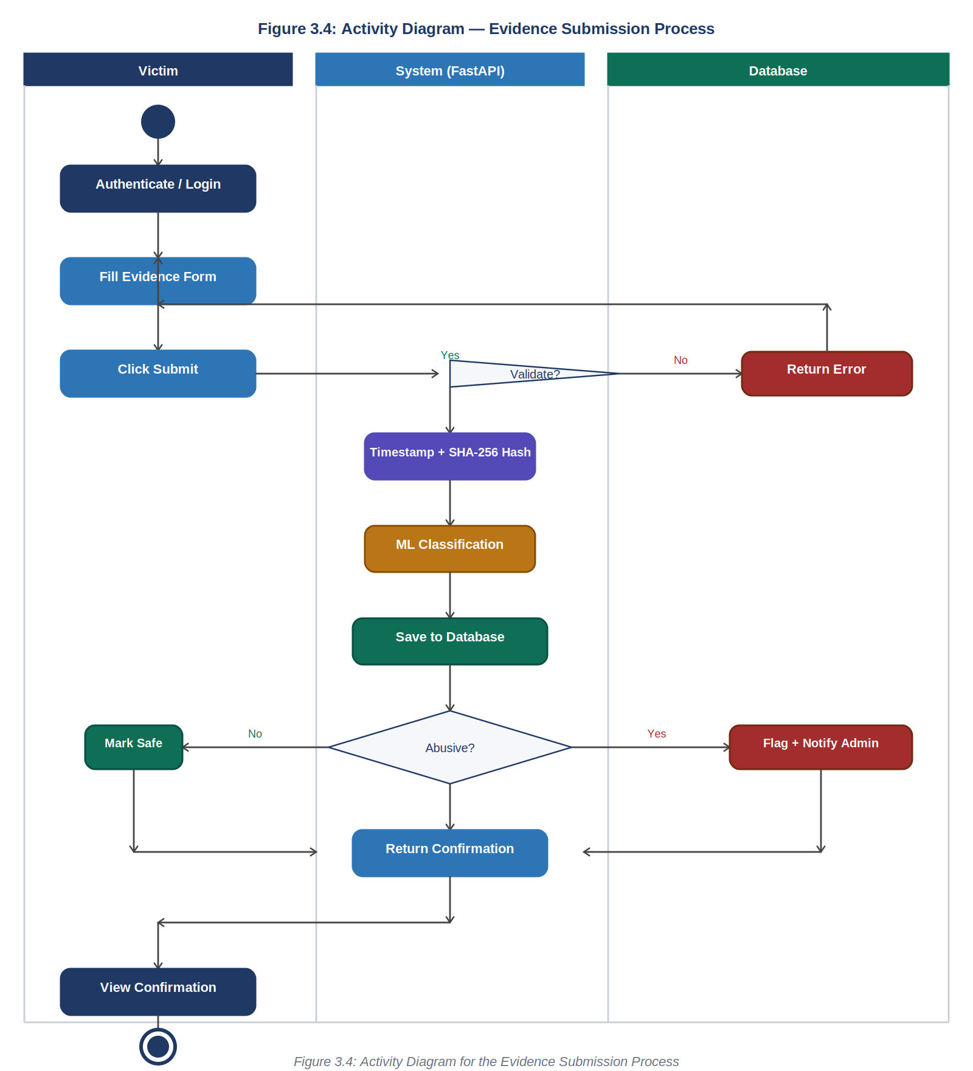
Figure 3.5: Activity Diagram for the Evidence Submission Process

3.9.4 Sequence Diagram — Evidence Submission, Hashing and Classification
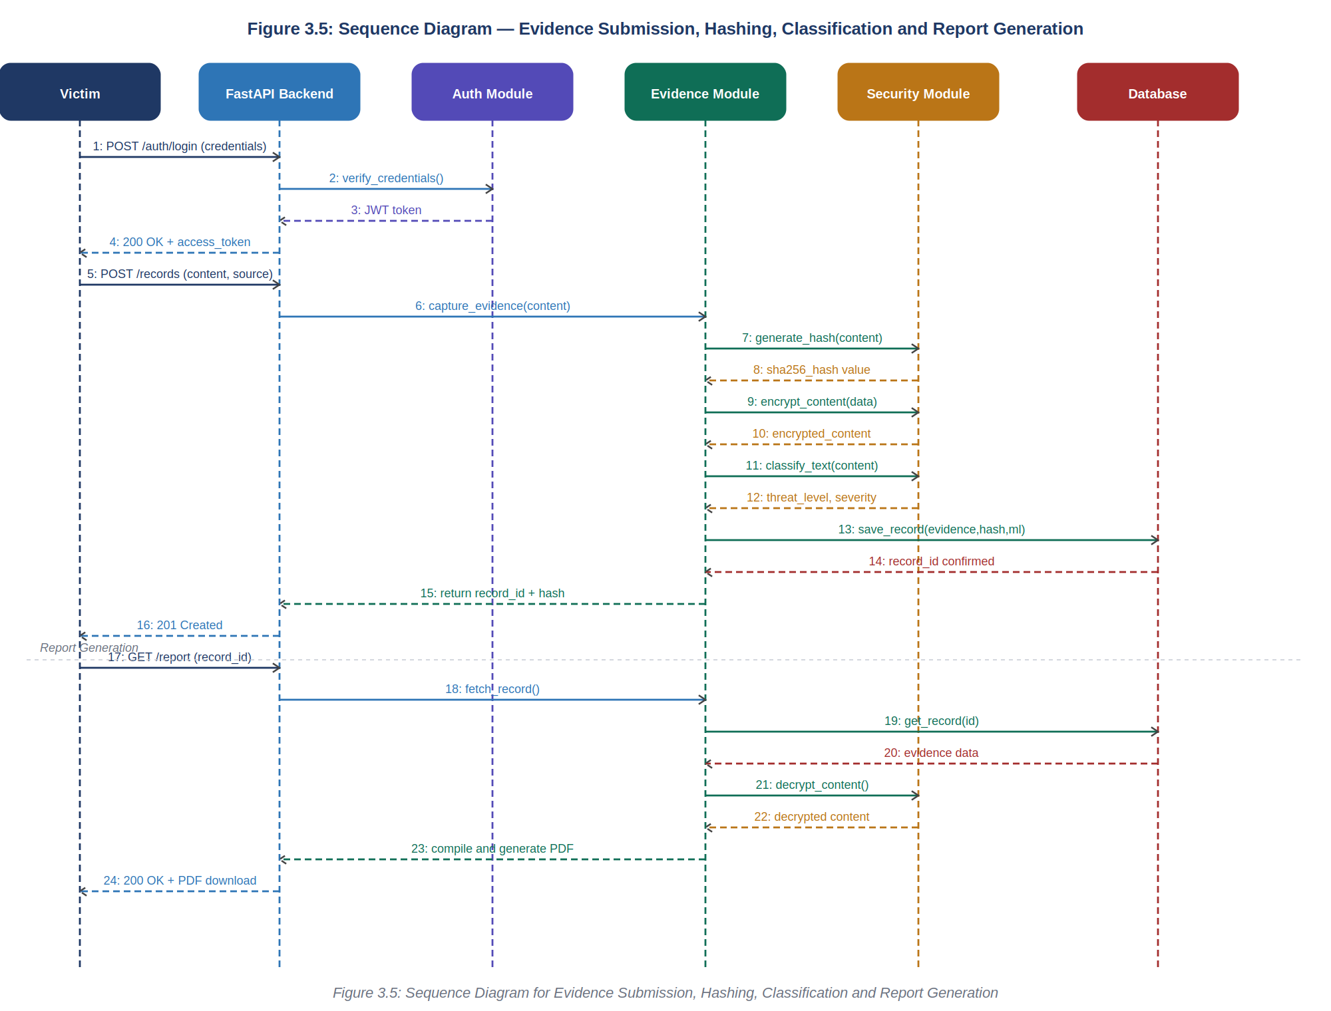
Figure 3.6: Sequence Diagram for Evidence Submission, Hashing, Classification and Report Generation

3.10 Non-Functional Requirements
Security: All evidence content shall be encrypted using AES before database storage. All API endpoints shall require JWT authentication. Passwords shall be hashed using bcrypt. HTTPS shall be enforced for all client-server communication. Justification: The system handles sensitive victim data. Any breach of confidentiality could cause further harm to already vulnerable individuals.
Integrity: A SHA-256 hash shall be generated for every evidence submission and stored immutably alongside the record. Any subsequent hash mismatch shall be flagged as evidence of tampering. Justification: The legal admissibility of digital evidence depends entirely on demonstrable integrity.
Reliability: Evidence submission and hashing operations shall be executed as atomic database transactions to prevent partial writes. Justification: A partial evidence write — where content is stored but the hash is not — would render the record legally unusable.
Performance: The system shall return a response to an evidence submission request within three seconds under normal load. PDF report generation shall complete within five seconds. Justification: Victims may be in distress; a slow or unresponsive system increases emotional burden.
Usability: The user interface shall be navigable without technical expertise. All form fields shall include clear labels and placeholder guidance. Error messages shall be written in plain, non-technical language. Justification: The primary users are abuse victims, not technical users.
Maintainability: The system shall be developed with a modular architecture so that individual components (e.g., the ML module) can be updated or replaced without affecting other modules. Justification: The ML model may require periodic retraining as new patterns of abuse emerge.
Scalability: The system architecture shall support horizontal scaling by separating the API layer from the database layer. Justification: As the user base grows, the system must be able to handle increased concurrent submissions without performance degradation.
Availability: The system shall target an uptime of not less than 99% during operational hours. Justification: Victims may need to submit evidence at any time, particularly immediately after an incident occurs.

3.11 System Candidate Classes and Class Diagram
Based on the requirement analysis, the following candidate classes were identified as the core structural elements of the system: User (a generalisation of Victim, Administrator, and LawEnforcementOfficer), Evidence, HashRecord, MLClassificationResult, Report, AuditLog, and Alert. These classes represent the primary entities and their relationships within the DigiSafe system.
Figure 3.7 presents the UML class diagram of the system, showing all candidate classes with their attributes and methods, visibility symbols (+ public, - private), and inter-class relationships with multiplicity indicators.
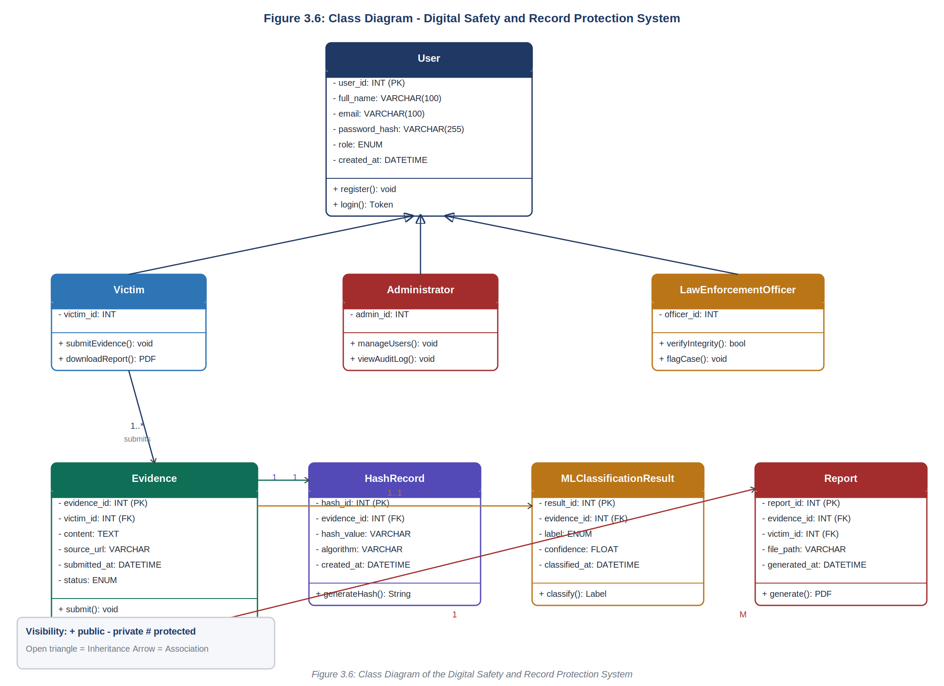
Figure 3.7: Class Diagram of the Digital Safety and Record Protection System

3.12 Algorithms and Flowcharts
This section presents the core algorithms that drive the system's key operations, along with their corresponding flowcharts.

3.12.1 Evidence Submission Algorithm
- Start.
- Victim authenticates (logs in) to the system.
- Victim enters evidence details (content type, source URL, and/or text content).
- System validates that all required fields are present and correctly formatted.
- If validation fails, return an error message to the victim and request re-entry.
- If validation succeeds, invoke the Hashing Module to generate a SHA-256 hash of the evidence content.
- Invoke the ML Classification Module to classify the evidence content.
- Persist the evidence record, hash value, and classification result to the database as a single atomic transaction.
- If the evidence is classified as abusive, flag the case and notify the administrator/law enforcement officer.
- Return a success response and confirmation to the victim.
- End.
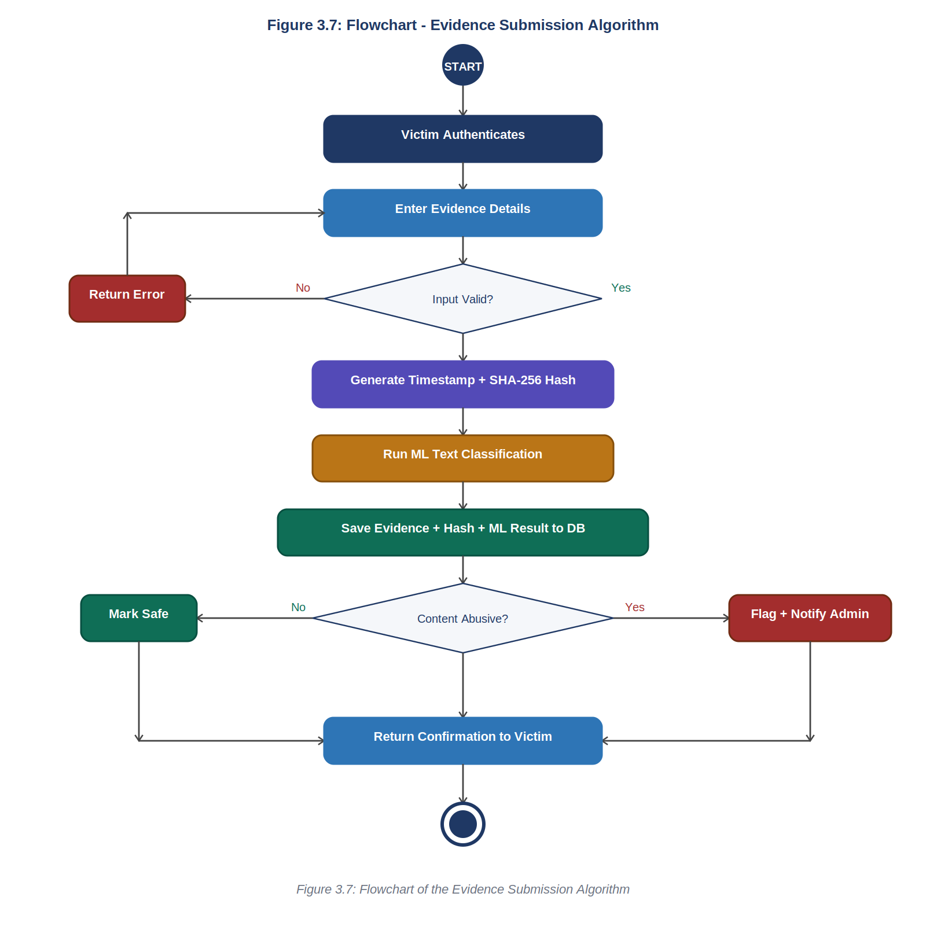
Figure 3.8: Flowchart of the Evidence Submission Algorithm

3.12.2 Cryptographic Hashing Algorithm
- Start.
- Receive the evidence content (text, file content, or URL string).
- Encode the content into bytes using UTF-8 encoding.
- Apply the SHA-256 hashing function (hashlib.sha256) to the encoded byte string.
- Generate the resulting 64-character hexadecimal digest.
- Record the timestamp at which the hash was generated.
- Store the hash value, algorithm identifier, and timestamp in the HASH_RECORD table, linked to the corresponding evidence record.
- End.
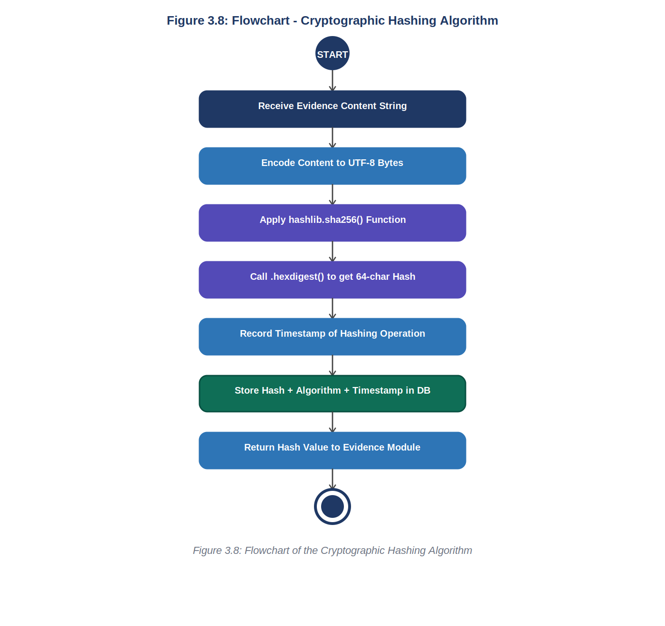
Figure 3.9: Flowchart of the Cryptographic Hashing Algorithm

3.12.3 ML Text Classification Algorithm
- Start.
- Receive the submitted text evidence.
- Pre-process the text: convert to lowercase, remove stop-words, and tokenise using NLTK.
- Transform the pre-processed text into TF-IDF feature vectors using Scikit-learn.
- Load the pre-trained Scikit-learn classification model.
- Predict the class label (abusive or non-abusive) and compute the associated confidence score.
- If the confidence score meets or exceeds the defined threshold and the label is abusive, flag the record for review.
- Otherwise, mark the record as non-abusive.
- Store the classification label, confidence score, and model version in the ML_CLASSIFICATION table.
- End.
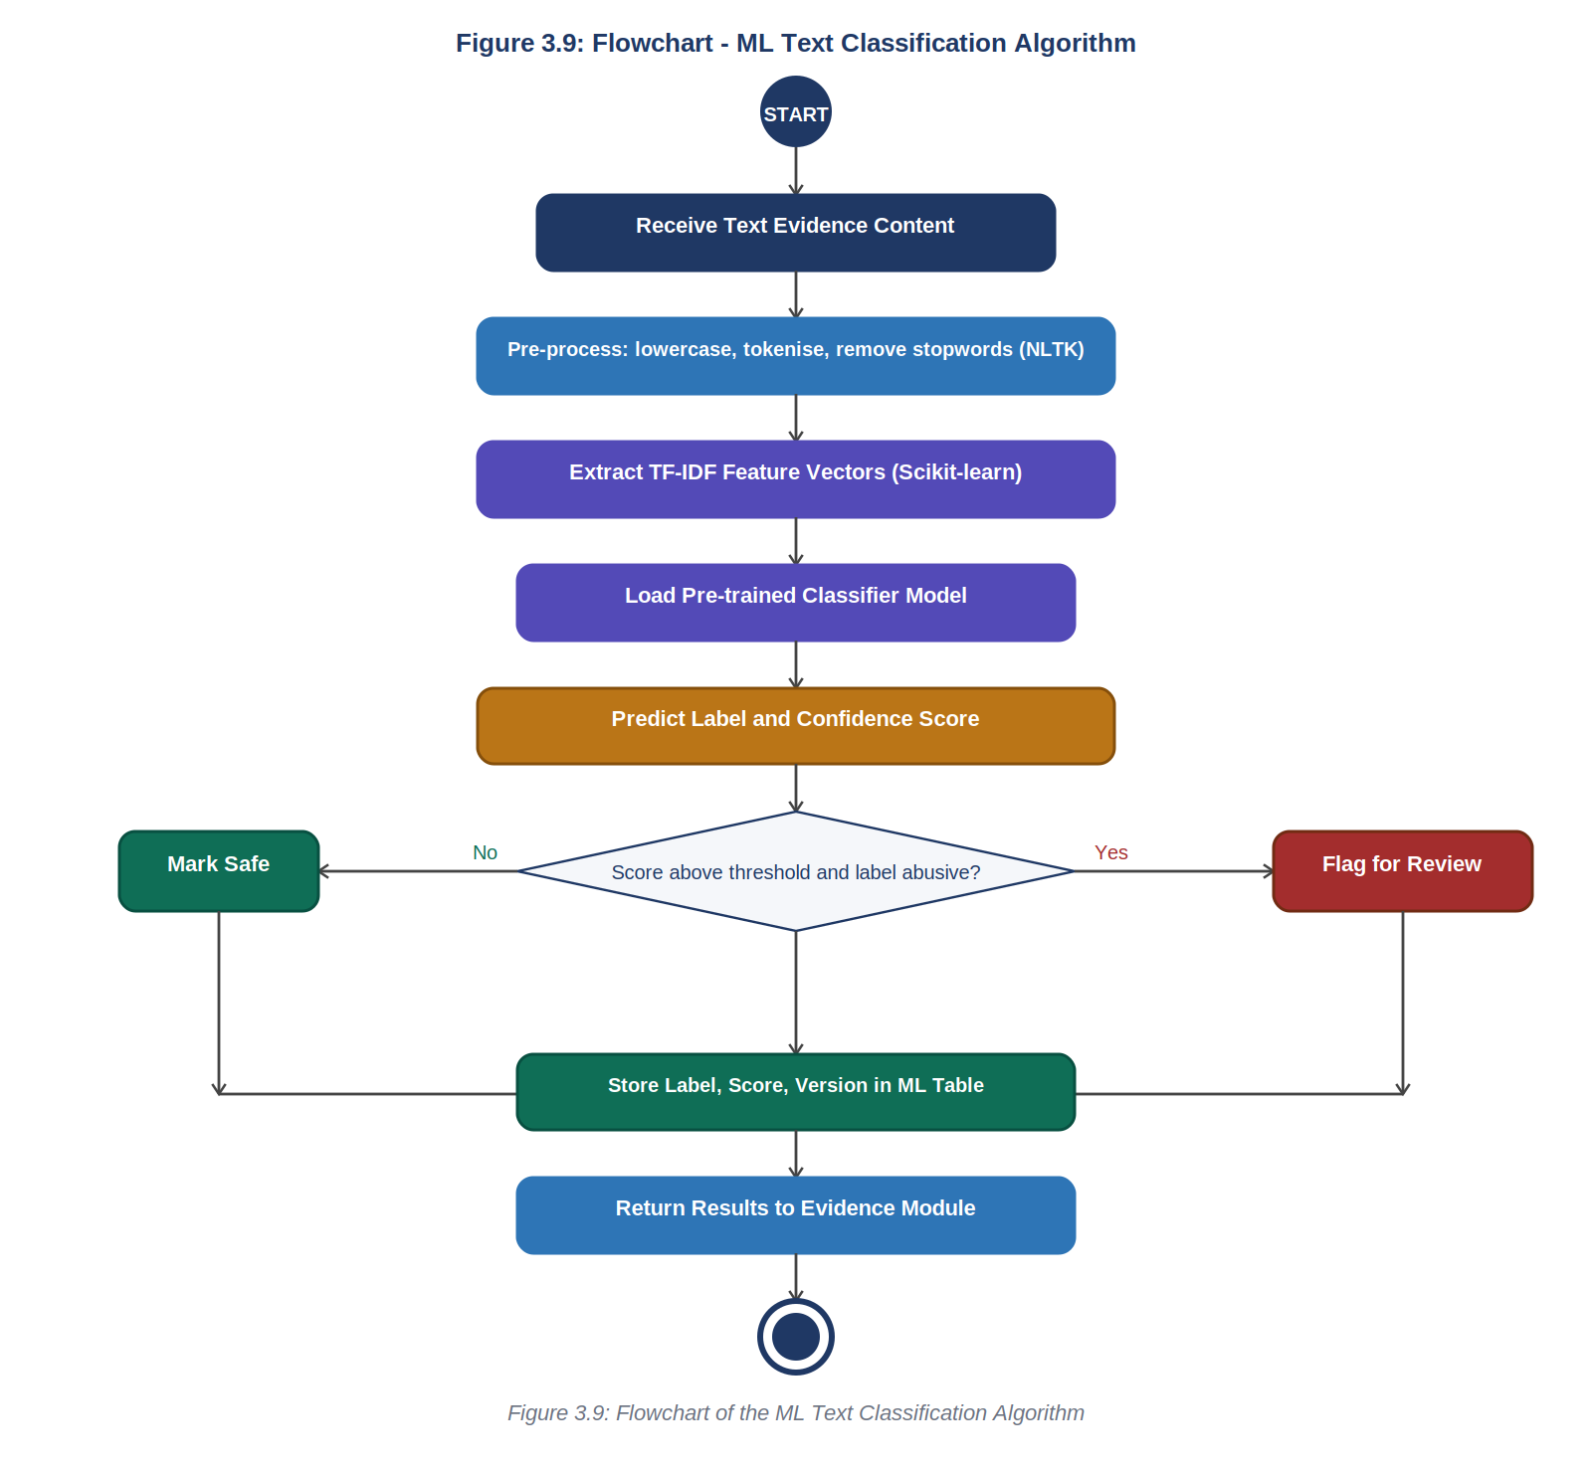
Figure 3.10: Flowchart of the ML Text Classification Algorithm

3.12.4 Automated Report Generation Algorithm
- Start.
- Receive a report generation request (from a victim or authorised reviewer) specifying an evidence record.
- Fetch the evidence content, hash value, and classification result from the database.
- If the record is not found, return an error message.
- Decrypt the evidence content using the AES decryption key.
- Compile the report data, including victim details (where authorised), evidence content, hash value, classification result, and timestamps.
- Render the compiled data into a structured PDF document using the FPDF library.
- Embed the evidence integrity hash and a digital footer on the generated report for verification purposes.
- Save the generated report file and log the report generation event in the REPORT table.
- Return the downloadable report to the requesting user.
- End.
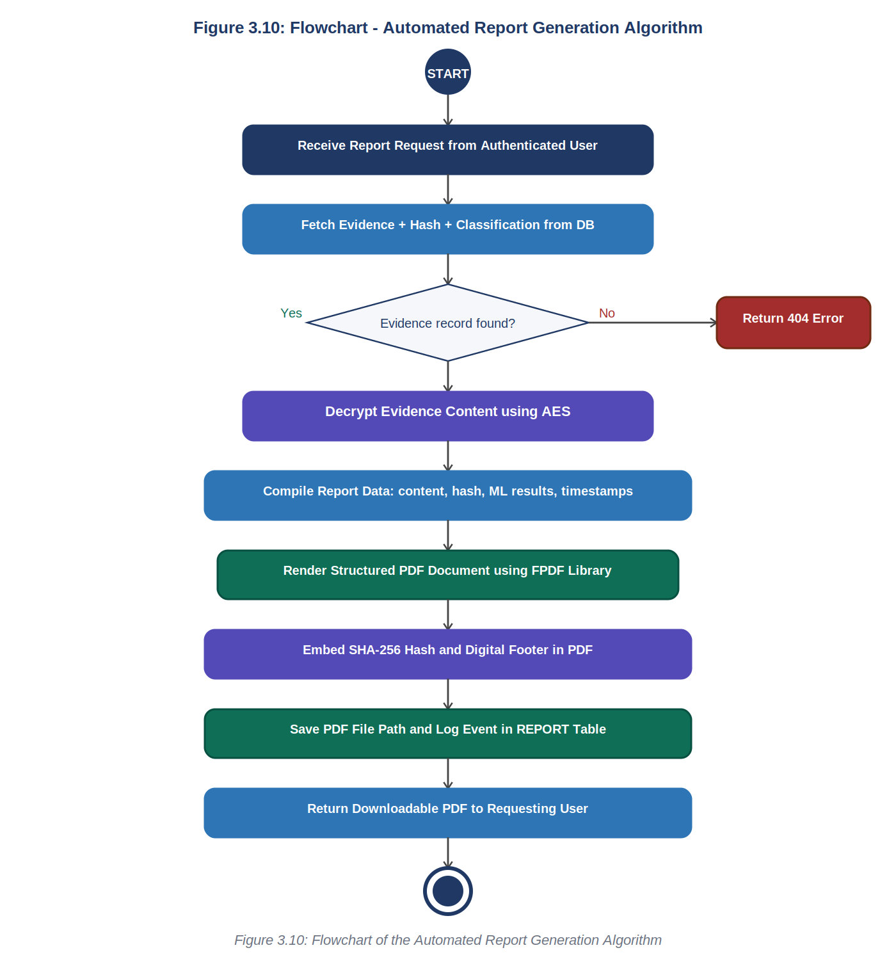
Figure 3.11: Flowchart of the Automated Report Generation Algorithm

3.13 Project Methods to be Employed
This project adopts the Agile Development Methodology as its overarching project management approach. Agile was chosen over a plan-driven (Waterfall) approach because the project involves iterative development of an ML classification component whose accuracy can only be assessed through repeated training and testing cycles. The Agile approach allows for continuous feedback, incremental delivery, and flexible response to changing requirements throughout the development process.

3.14 Software Process Model and Justification for Model Choice
The Agile (Scrum-inspired) software process model has been adopted for the development of this system. Under this model, development proceeds through a series of short iterative cycles (sprints), each delivering a working, testable increment of the system. The development roadmap consists of four sprints: Sprint 1 — Authentication and Database Setup; Sprint 2 — Evidence Capture, Hashing, and Encryption; Sprint 3 — ML Classification Module and Report Generation; Sprint 4 — Frontend Integration, Testing, and Documentation.
This model was selected over plan-driven models such as the Waterfall model for the following reasons:
- Iterative Refinement: The accuracy of the ML text classification component can only be meaningfully improved through repeated cycles of training, testing, and parameter tuning — a process that is natively supported by Agile but incompatible with the sequential nature of Waterfall.
- Early and Continuous Feedback: Agile allows the developer to demonstrate working increments to the project supervisor at regular intervals, enabling early identification of design issues.
- Flexibility to Changing Requirements: As legal and security considerations are clarified during development, Agile accommodates the incorporation of new requirements without requiring a complete redesign.
- Risk Reduction: By delivering small, testable increments, critical risks — such as hashing correctness or classification reliability — are identified and mitigated early in the development cycle.
- Suitability for a Single-Developer Academic Project: Agile's lightweight ceremonies make it highly suitable for solo development within an academic timeline.

3.15 Project Design Consideration (Logical Designs)

3.15.1 UI Design (Wireframes)
The user interface was designed with simplicity and emotional sensitivity in mind, recognising that victims may be interacting with the system while distressed. The wireframes below present the key screens of the DigiSafe system, showing the layout, navigation, and interactive elements of each interface.

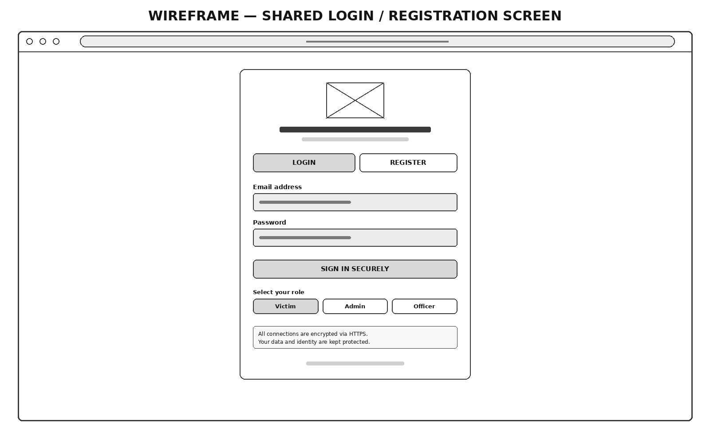
Figure 3.12: Wireframe of the Shared Login / Registration Screen
Figure 3.12 shows the shared login and registration screen. The interface uses a clean, card-based layout centred on a dark background. Role selection (Victim, Admin, Officer) is provided at the bottom of the login form, ensuring each user type is directed to the appropriate dashboard upon authentication.

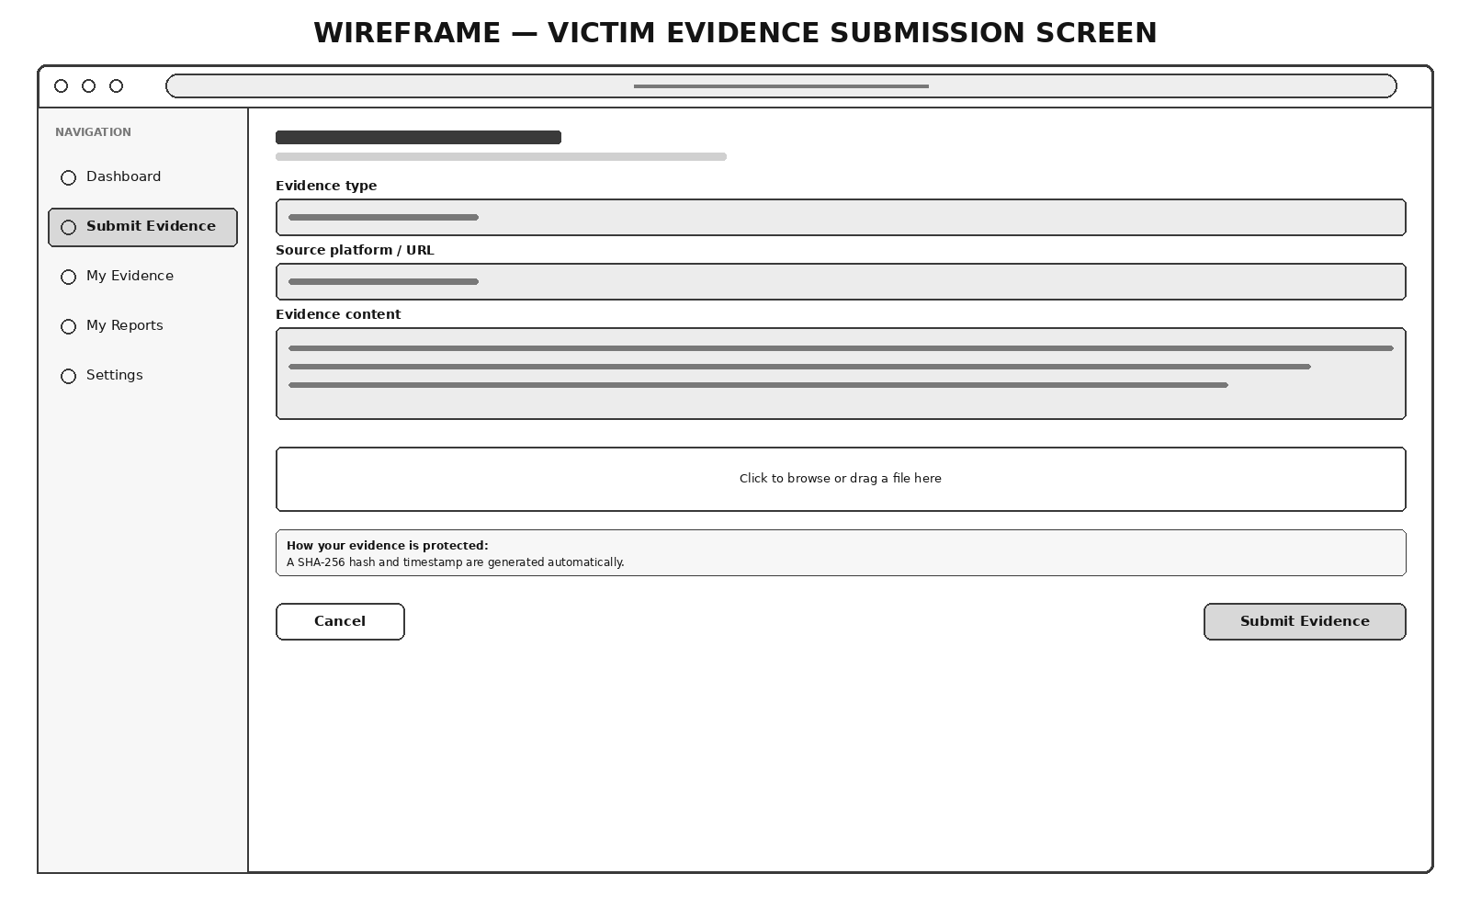
Figure 3.13: Wireframe of the Victim Evidence Submission Interface
Figure 3.13 presents the evidence submission screen available to authenticated victims. The interface provides clearly labelled fields for evidence type, source platform/URL, evidence content, and an optional file attachment. A security notice at the bottom of the form informs the victim that their submission will be immediately timestamped and cryptographically hashed upon submission.

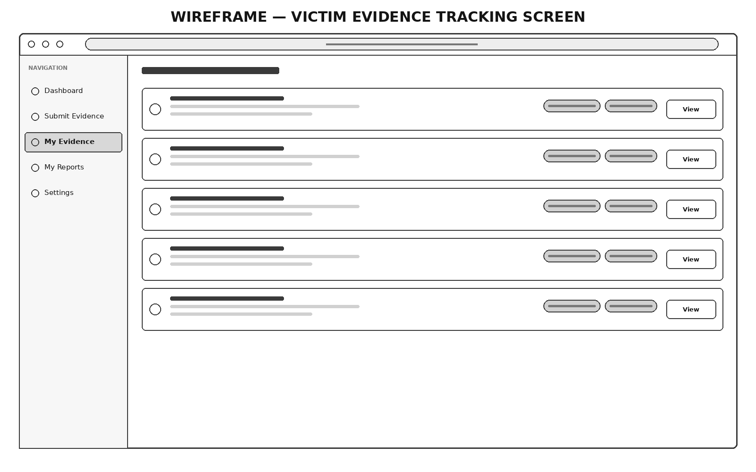
Figure 3.14: Wireframe of the Victim Evidence Tracking Screen
Figure 3.14 shows the evidence tracking screen, where victims can view all their submitted evidence records. Each record card displays the evidence ID, submission date and time, a content preview, the SHA-256 hash integrity status, and the ML-assigned severity level. Quick-action buttons allow victims to view full details or download the evidence report.

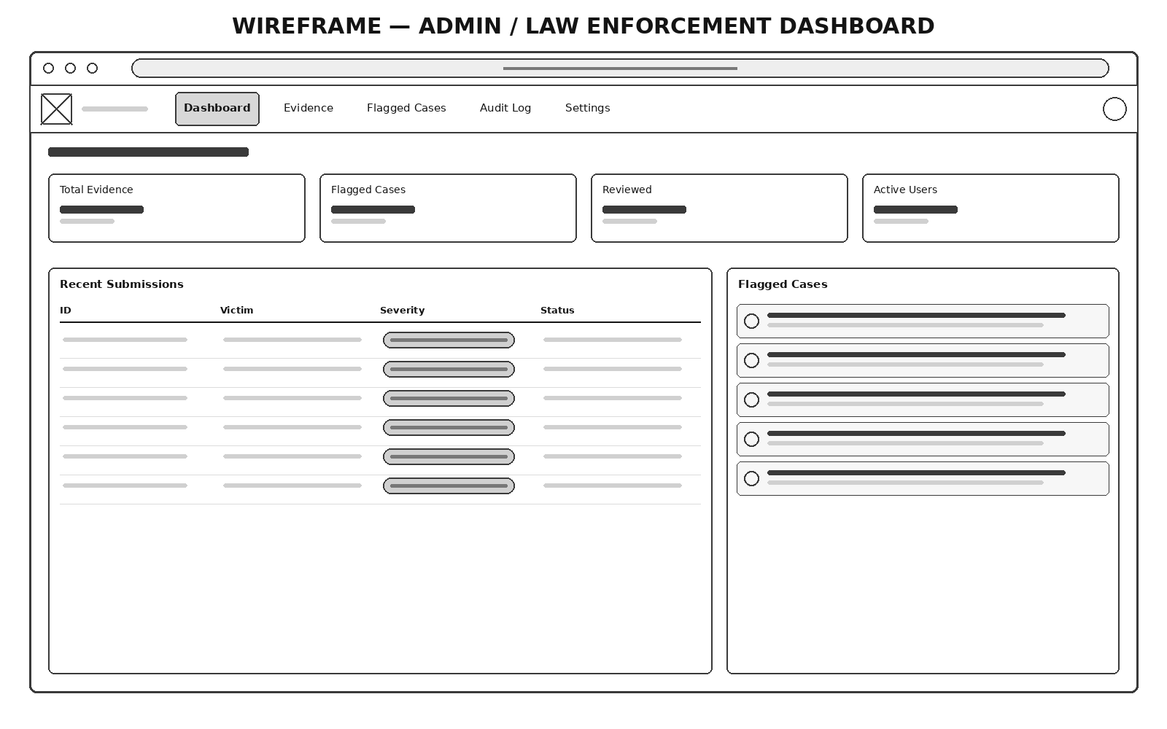
Figure 3.15: Wireframe of the Admin / Law Enforcement Dashboard
Figure 3.15 presents the administrator overview dashboard. Summary statistics cards at the top display the total number of evidence submissions, flagged cases, reviewed records, and active users. A table below lists the most recent submissions with their severity and status, and a flagged cases panel highlights urgent cases requiring immediate attention.

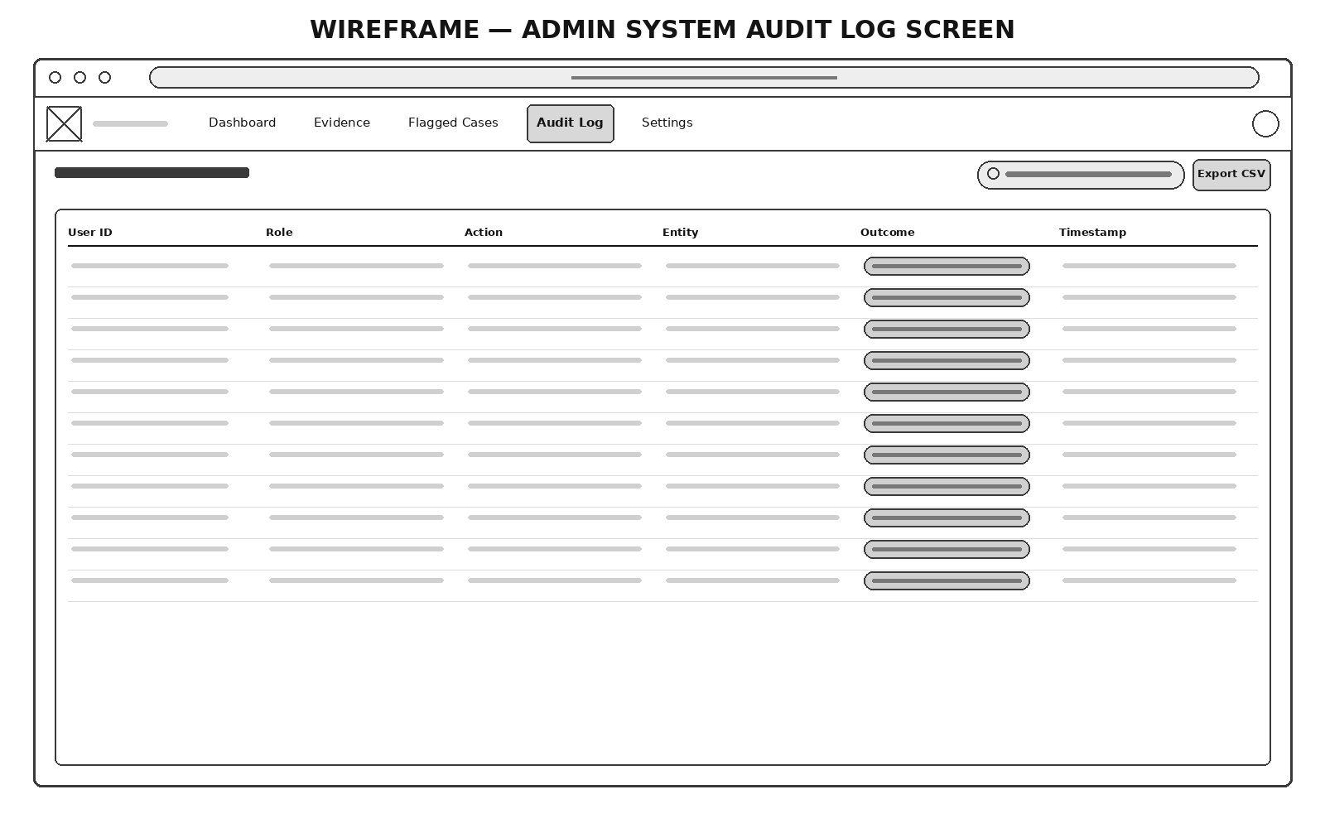
Figure 3.16: Wireframe of the Admin System Audit Log Screen
Figure 3.16 shows the system audit log screen, accessible only to administrators. Every significant system action — including evidence submissions, report downloads, logins, and administrative actions — is recorded in chronological order with the user ID, role, action description, and outcome. The log is searchable and can be exported to CSV for external review.

3.15.2 DB Design — Entity-Relationship Diagram
Figure 3.17 presents the Entity-Relationship (ER) diagram of the proposed database, showing the entities, primary keys (PK), foreign keys (FK), and their relationships with multiplicity indicators. The diagram reflects a normalised relational database design with six core tables: USERS, EVIDENCE, HASH_RECORD, ML_CLASSIFICATION, REPORT, AUDIT_LOG, and ALERT.

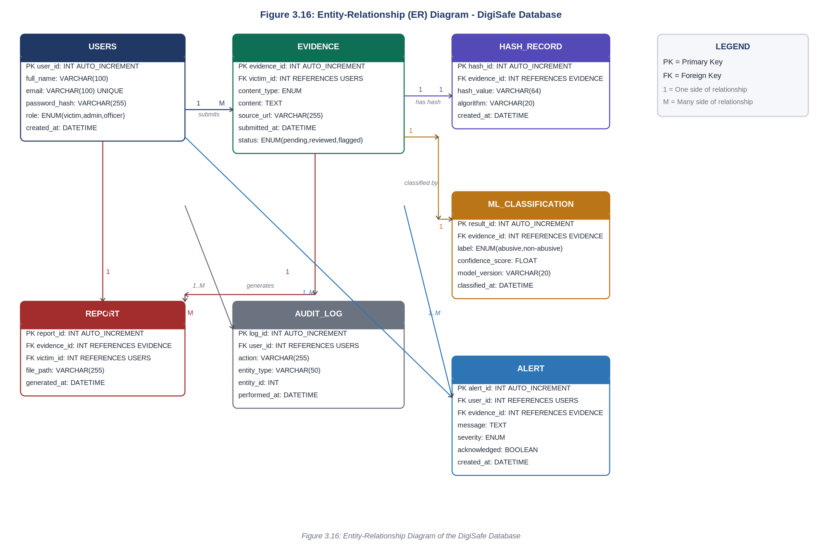
Figure 3.17: Entity-Relationship Diagram of the Digital Safety and Record Protection System Database

Database Schema
The system's database schema, derived from the entities in the ER diagram, is summarised below:
USERS: user_id (PK), full_name, email, password_hash, role, created_at
EVIDENCE: evidence_id (PK), victim_id (FK → USERS), content_type, content, source_url, submitted_at, status
HASH_RECORD: hash_id (PK), evidence_id (FK → EVIDENCE), hash_value, algorithm, created_at
ML_CLASSIFICATION: result_id (PK), evidence_id (FK → EVIDENCE), label, confidence_score, model_version, classified_at
REPORT: report_id (PK), evidence_id (FK → EVIDENCE), victim_id (FK → USERS), file_path, generated_at
AUDIT_LOG: log_id (PK), user_id (FK → USERS), action, entity_type, entity_id, performed_at
ALERT: alert_id (PK), user_id (FK → USERS), evidence_id (FK → EVIDENCE), message, severity, acknowledged, created_at
These tables follow the structure illustrated in Figure 3.17, each linked to the EVIDENCE and USERS tables through foreign key relationships to maintain referential integrity.

3.16 Developmental Tools
The following tools and technologies were selected for the development of the Digital Safety and Record Protection System, each chosen for a specific role in the development workflow:
Python 3.x: The primary programming language for backend development. Python was selected for its extensive ecosystem of libraries relevant to this project, including hashlib for cryptographic hashing, scikit-learn and NLTK for machine learning and natural language processing, and FPDF for PDF generation.
FastAPI: A modern, high-performance Python web framework used to build the RESTful API backend. FastAPI was chosen for its native support for asynchronous operations, automatic OpenAPI documentation generation, and built-in request validation through Pydantic models.
SQLAlchemy: The Object-Relational Mapper (ORM) used to define and interact with the database schema in Python. SQLAlchemy abstracts raw SQL queries, enabling safer and more maintainable database operations.
SQLite / MySQL: The relational database management system used for persistent data storage. SQLite is used during development and testing for its zero-configuration simplicity; MySQL will be used in the production environment for its robustness and concurrent access support.
Scikit-learn: The machine learning library used to build and train the text classification model. Specifically, a TF-IDF vectoriser combined with a Multinomial Naive Bayes or Logistic Regression classifier will be used to detect abusive content in submitted evidence text.
NLTK (Natural Language Toolkit): Used for text pre-processing tasks including tokenisation, stop-word removal, and stemming, which are applied to evidence text before it is passed to the Scikit-learn classification model.
Python Cryptography Library: Used to implement AES encryption for protecting evidence content stored in the database. This ensures that even if database access is compromised, the evidence content remains unreadable without the decryption key.
FPDF: A lightweight Python library used to generate structured PDF evidence reports. FPDF was selected for its simplicity and ability to produce well-formatted, multi-page documents without requiring external dependencies.
HTML5, CSS3 and JavaScript: Used to build the Presentation Layer (frontend) of the system. Bootstrap 5 is used as the CSS framework to ensure a responsive and accessible user interface across different screen sizes and devices.
Visual Studio Code: The integrated development environment (IDE) used for all code authoring, debugging, and version management tasks. VS Code's Python extension provides real-time linting, autocomplete, and integrated terminal support.
Git and GitHub: Used for version control and source code management. All code changes are committed to a GitHub repository, enabling rollback, branching for feature development, and a transparent development history.
Uvicorn: The ASGI (Asynchronous Server Gateway Interface) server used to run the FastAPI application. Uvicorn provides the high-performance event loop required to handle concurrent API requests efficiently.

CHAPTER 4
IMPLEMENTATION, TESTING, AND RESULTS

4.1 IMPLEMENTATION

4.1.1 Introduction
This chapter presents the practical implementation of the Digital Safety and Record Protection System (DigiSafe) whose architecture, requirements, and design were established in Chapter 3. It describes how each design component — the Victim Web Interface, the Admin/Law Enforcement Dashboard, the FastAPI backend, the Authentication Module, the Evidence Capture Module, the Cryptographic Hashing and Encryption Module, the Machine Learning Detection Module, and the Report Generation Module — was translated into working code. Representative code listings are presented for the key modules, followed by a description of the testing strategy adopted (UI, database, integration, and system testing) and a discussion of the results obtained.
Two of the sub-sections in this chapter — the Checksum Data Recovery Technique (Section 4.1.8) and the Data Shuffling Method (Section 4.1.9) — are implemented as extensions of the core Cryptographic Integrity Module described in Chapter 3. The “checksum data recovery technique” is realised through the system's SHA-256 hash re-computation and comparison process, which detects when a stored evidence record has been altered and flags it accordingly; the “data shuffling method” is realised through the AES-based transformation applied to evidence content before it is persisted, which obscures the plaintext structure of the stored data. Both are presented below with their corresponding code listings.

4.1.2 Implementation of the Frontend

UI Designs
The frontend of DigiSafe was implemented using HTML5, CSS3, JavaScript, and the Bootstrap 5 framework. Four primary screens are illustrated below: the shared Login/Registration screen, the Victim Evidence Submission screen, the Victim Evidence Tracking screen, and the Admin/Law Enforcement Dashboard. A fifth screen, the System Audit Log, was also implemented to let administrators search system actions and export them to CSV, but is not pictured here. Each screen was built to be responsive across desktop and mobile viewports, and form validation is performed client-side before any request is sent to the FastAPI backend.
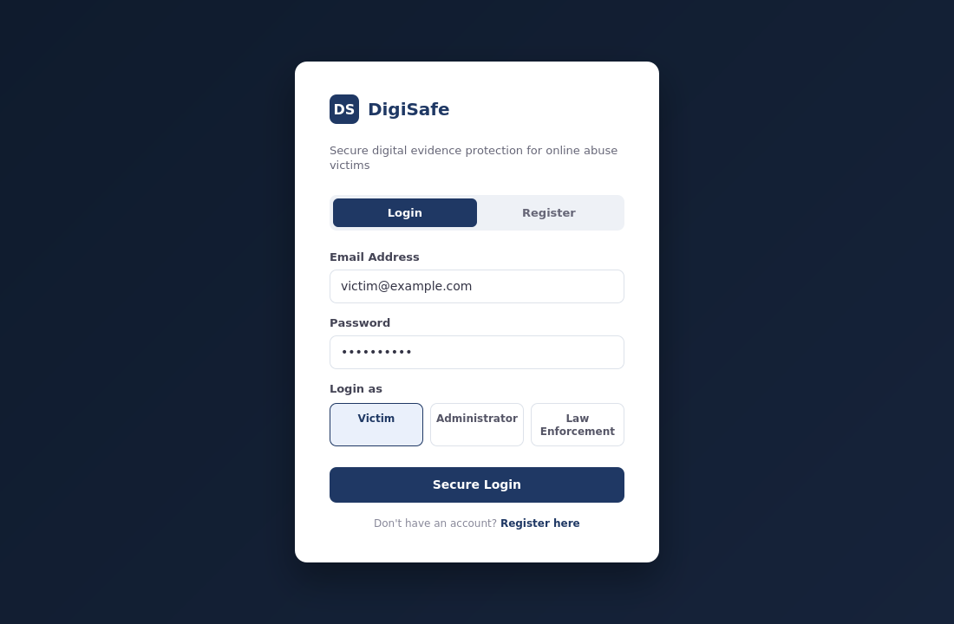
Figure 4.1: Implemented Login / Registration Screen
This screen lets a user log in or register with an email address and password. A role selector at the bottom lets the user choose whether they are logging in as a Victim, an Administrator, or a Law Enforcement Officer, so the system knows which dashboard to open for them after login.
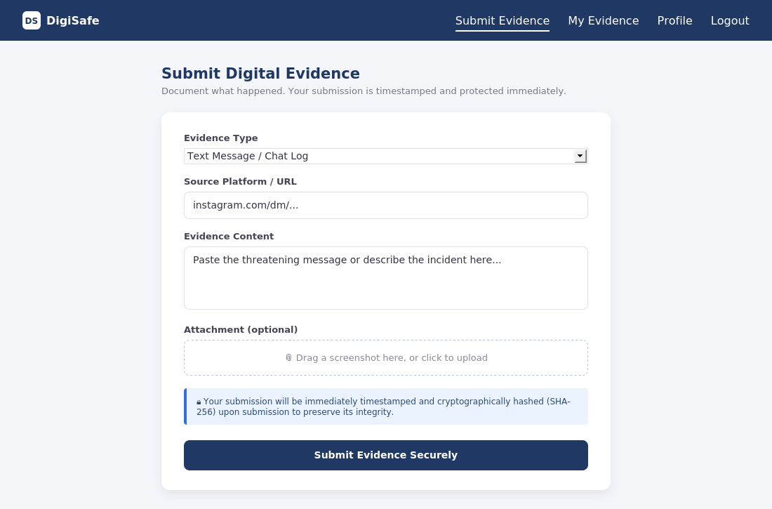
Figure 4.2: Implemented Evidence Submission Screen
This screen lets a victim submit a piece of evidence. They choose the evidence type, enter the source platform or URL, type or paste the evidence content, and optionally attach a file such as a screenshot. A notice on the form reminds the victim that the submission will be timestamped and hashed as soon as it is sent.
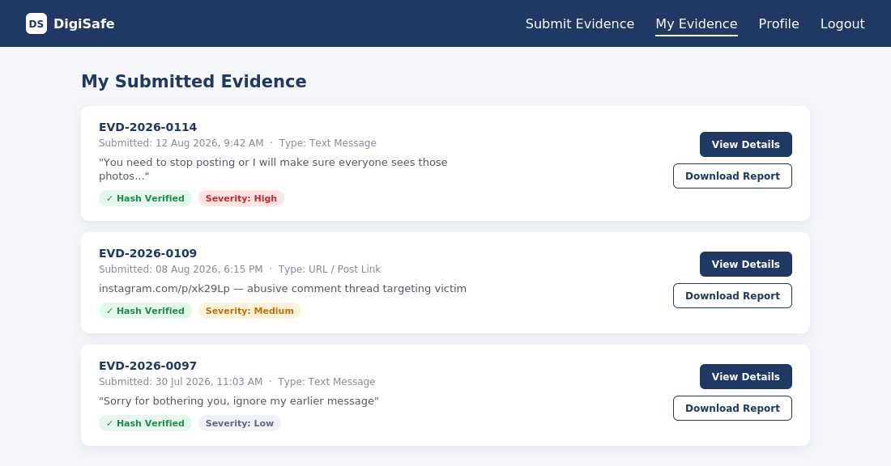
Figure 4.3: Implemented Evidence Tracking Screen
This screen lists all the evidence a victim has submitted. Each entry shows the evidence ID, when it was submitted, a short preview of the content, whether its hash has been verified, and how severe the ML system judged it to be. Buttons let the victim view the full record or download its report.
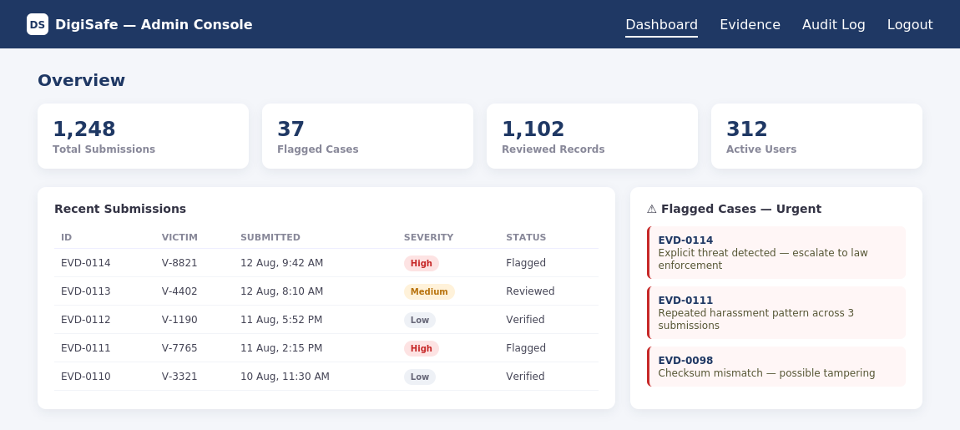
Figure 4.4: Implemented Admin / Law Enforcement Dashboard
This screen gives administrators and law enforcement officers an overview of the system. Summary cards show the total number of submissions, flagged cases, reviewed records, and active users. A table lists recent submissions with their severity and status, and a side panel highlights urgent cases that need attention.

UI Code Listing
Listing 4.1 shows an excerpt of the HTML/JavaScript implementation of the evidence submission form, including the client-side call to the FastAPI evidence endpoint.

<!-- evidence_submit.html -->
<form id="evidenceForm" class="card p-4 shadow-sm">
<div class="mb-3">
<label class="form-label">Evidence Type</label>
<select id="contentType" class="form-select" required>
<option value="text">Text Message</option>
<option value="url">URL / Post Link</option>
<option value="file">File Attachment</option>
</select>
</div>
<div class="mb-3">
<label class="form-label">Source Platform / URL</label>
<input type="text" id="sourceUrl" class="form-control">
</div>
<div class="mb-3">
<label class="form-label">Evidence Content</label>
<textarea id="content" class="form-control" rows="5" required></textarea>
</div>
<div class="mb-3">
<label class="form-label">Attachment (optional)</label>
<input type="file" id="attachment" class="form-control">
</div>
<div class="alert alert-info small">
Your submission will be immediately timestamped and cryptographically
hashed upon submission to preserve its integrity.
</div>
<button type="submit" class="btn btn-primary w-100">Submit Evidence</button>
</form>

<script>
document.getElementById('evidenceForm').addEventListener('submit', async (e) => {
e.preventDefault();
const formData = new FormData();
formData.append('content_type', document.getElementById('contentType').value);
formData.append('source_url', document.getElementById('sourceUrl').value);
formData.append('content', document.getElementById('content').value);
const file = document.getElementById('attachment').files[0];
if (file) formData.append('file', file);

const response = await fetch('/api/evidence/submit', {
method: 'POST',
headers: { 'Authorization': `Bearer ${localStorage.getItem('token')}` },
body: formData
});
const result = await response.json();
if (response.ok) {
alert(`Evidence submitted. Hash: ${result.hash_value}`);
window.location.href = '/evidence/track';
} else {
alert(result.detail || 'Submission failed. Please try again.');
}
});
</script>

Listing 4.1: HTML/JavaScript Implementation of the Evidence Submission Form

4.1.3 Implementation of the Backend

Backend Designs
The backend was implemented as a modular FastAPI application, mirroring the Business Logic Layer described in Section 3.2. The project directory is organised into distinct packages for routers (API endpoints), models (SQLAlchemy ORM classes), schemas (Pydantic request/response models), services (business logic such as hashing, encryption, ML classification, and report generation), and core utilities (configuration and security). This separation of concerns allows each module — Authentication, Evidence Capture, Security, ML Detection, and Report Generation — to be developed, tested, and maintained independently, consistent with the Maintainability non-functional requirement in Section 3.10.

digisafe_backend/
├── main.py # FastAPI app entrypoint
├── core/
│ ├── config.py # environment & app settings
│ └── security.py # JWT, bcrypt utilities
├── models/
│ ├── user.py
│ ├── evidence.py
│ ├── hash_record.py
│ ├── ml_classification.py
│ ├── report.py
│ ├── audit_log.py
│ └── alert.py
├── schemas/ # Pydantic request/response models
├── routers/
│ ├── auth.py
│ ├── evidence.py
│ ├── admin.py
│ └── reports.py
└── services/
├── hashing_service.py
├── encryption_service.py
├── ml_service.py
└── report_service.py

Figure 4.5: Backend Directory / Module Structure

Backend Code Listing
Listing 4.2 shows the FastAPI application entrypoint, including router registration and CORS configuration.

# main.py
from fastapi import FastAPI
from fastapi.middleware.cors import CORSMiddleware
from routers import auth, evidence, admin, reports
from models import base
from core.database import engine

base.Base.metadata.create_all(bind=engine)

app = FastAPI(title="DigiSafe API", version="1.0.0")

app.add_middleware(
CORSMiddleware,
allow_origins=["*"],
allow_credentials=True,
allow_methods=["*"],
allow_headers=["*"],
)

app.include_router(auth.router, prefix="/api/auth", tags=["Authentication"])
app.include_router(evidence.router, prefix="/api/evidence", tags=["Evidence"])
app.include_router(admin.router, prefix="/api/admin", tags=["Admin"])
app.include_router(reports.router, prefix="/api/reports", tags=["Reports"])

Listing 4.2: FastAPI Application Entrypoint (main.py)

4.1.4 The Login Module
The Login Module implements the Authentication and Access Control Module described in Section 3.3.3. Passwords are hashed with bcrypt before storage, and a JSON Web Token (JWT) is issued upon successful authentication, encoding the user's identity and role (Victim, Administrator, or Law Enforcement Officer) so that role-based access control can be enforced on protected endpoints.

# routers/auth.py
from fastapi import APIRouter, Depends, HTTPException
from sqlalchemy.orm import Session
from core.security import verify_password, create_access_token
from core.database import get_db
from models.user import User
from schemas.auth import LoginRequest, TokenResponse

router = APIRouter()

@router.post("/login", response_model=TokenResponse)
def login(payload: LoginRequest, db: Session = Depends(get_db)):
user = db.query(User).filter(User.email == payload.email).first()
if not user or not verify_password(payload.password, user.password_hash):
raise HTTPException(status_code=401, detail="Invalid email or password")
token = create_access_token(
data={"sub": str(user.user_id), "role": user.role}
)
return TokenResponse(access_token=token, token_type="bearer", role=user.role)

Listing 4.3: Login Endpoint Implementation (routers/auth.py)

# core/security.py
from datetime import datetime, timedelta
from passlib.context import CryptContext
import jwt

pwd_context = CryptContext(schemes=["bcrypt"], deprecated="auto")
SECRET_KEY = "<loaded from environment variable>"
ALGORITHM = "HS256"
ACCESS_TOKEN_EXPIRE_MINUTES = 60

def hash_password(password: str) -> str:
return pwd_context.hash(password)

def verify_password(plain: str, hashed: str) -> bool:
return pwd_context.verify(plain, hashed)

def create_access_token(data: dict) -> str:
payload = data.copy()
payload["exp"] = datetime.utcnow() + timedelta(minutes=ACCESS_TOKEN_EXPIRE_MINUTES)
return jwt.encode(payload, SECRET_KEY, algorithm=ALGORITHM)

Listing 4.4: JWT and Password Hashing Utilities (core/security.py)

4.1.5 File Upload Module
The File Upload Module extends the Evidence Capture Module (Section 3.3.4) to support optional file attachments — such as screenshots or exported chat logs — alongside text and URL evidence. Uploaded files are validated for type and size, stored on the server file system under a unique, non-guessable filename, and their path is recorded in the EVIDENCE table. Each uploaded file is also passed to the Hashing Module (Section 4.1.6) so that its integrity can be verified independently of the surrounding text evidence.

# routers/evidence.py (excerpt)
import os, uuid
from fastapi import APIRouter, Depends, UploadFile, File, Form
from services.hashing_service import generate_sha256_hash

UPLOAD_DIR = "storage/evidence_files"
ALLOWED_EXTENSIONS = {".png", ".jpg", ".jpeg", ".pdf", ".txt"}
MAX_FILE_SIZE_MB = 10

@router.post("/submit")
async def submit_evidence(
content_type: str = Form(...),
source_url: str = Form(None),
content: str = Form(...),
file: UploadFile = File(None),
current_user = Depends(get_current_user),
db: Session = Depends(get_db),
):
file_path = None
if file:
ext = os.path.splitext(file.filename)[1].lower()
if ext not in ALLOWED_EXTENSIONS:
raise HTTPException(400, "Unsupported file type")
file_bytes = await file.read()
if len(file_bytes) > MAX_FILE_SIZE_MB * 1024 * 1024:
raise HTTPException(400, "File exceeds maximum allowed size")
unique_name = f"{uuid.uuid4().hex}{ext}"
file_path = os.path.join(UPLOAD_DIR, unique_name)
with open(file_path, "wb") as f:
f.write(file_bytes)

# proceed to hashing, encryption, ML classification and persistence
# (see Listings 4.5, 4.7 and 4.9)
...

Listing 4.5: File Upload Handling within the Evidence Submission Endpoint

4.1.6 Implementation of the Hashing Method
The hashing method implements the Cryptographic Hashing and Encryption Module (Section 3.3.5) and the Cryptographic Hashing Algorithm (Section 3.12.2). It uses Python's built-in hashlib library to apply the SHA-256 algorithm to the UTF-8 encoded evidence content, producing a 64-character hexadecimal digest that acts as a tamper-evident digital fingerprint for the record.

# services/hashing_service.py
import hashlib
from datetime import datetime

def generate_sha256_hash(content: str) -> dict:
"""Generate a SHA-256 hash for a piece of evidence content."""
encoded_content = content.encode("utf-8")
hash_value = hashlib.sha256(encoded_content).hexdigest()
return {
"hash_value": hash_value,
"algorithm": "SHA-256",
"created_at": datetime.utcnow(),
}

def generate_file_hash(file_bytes: bytes) -> str:
"""Generate a SHA-256 hash for an uploaded file's binary content."""
return hashlib.sha256(file_bytes).hexdigest()

Listing 4.6: SHA-256 Hashing Implementation (services/hashing_service.py)

4.1.7 Implementation of the Data Module
The Data Module implements the Database Management Component (Section 3.3.8) and the database schema presented in Section 3.15.2. SQLAlchemy's declarative ORM is used to define the USERS, EVIDENCE, HASH_RECORD, ML_CLASSIFICATION, REPORT, AUDIT_LOG, and ALERT tables, with foreign-key relationships enforcing referential integrity between evidence records, their owners, and their associated hash and classification results.

# models/evidence.py
from sqlalchemy import Column, Integer, String, Text, DateTime, ForeignKey
from sqlalchemy.orm import relationship
from datetime import datetime
from models.base import Base

class Evidence(Base):
__tablename__ = "evidence"

evidence_id = Column(Integer, primary_key=True, index=True)
victim_id = Column(Integer, ForeignKey("users.user_id"), nullable=False)
content_type = Column(String(20), nullable=False)
content = Column(Text, nullable=False) # AES-encrypted at rest
source_url = Column(String(500), nullable=True)
submitted_at = Column(DateTime, default=datetime.utcnow)
status = Column(String(20), default="pending")

owner = relationship("User", back_populates="evidence_records")
hash_record = relationship("HashRecord", uselist=False, back_populates="evidence")
classification = relationship("MLClassification", uselist=False, back_populates="evidence")
reports = relationship("Report", back_populates="evidence")

Listing 4.7: SQLAlchemy ORM Model for the EVIDENCE Table (models/evidence.py)

4.1.8 Implementation of the Checksum Data Recovery Technique
The checksum data recovery technique builds on the hashing method of Section 4.1.6 to provide an integrity verification and recovery-signalling mechanism for stored evidence. Whenever a record is retrieved — for example, when an administrator or law enforcement officer opens an evidence file for review — the system re-computes the SHA-256 checksum of the stored content and compares it against the checksum captured at submission time. A mismatch indicates that the underlying data has been altered or corrupted since it was originally captured. In that event, the system does not silently repair the record (which would itself undermine legal admissibility); instead, it marks the record as compromised, raises an ALERT entry, and preserves both the original stored checksum and the newly computed checksum so that the discrepancy itself becomes part of the auditable evidence trail.

# services/hashing_service.py (continued)

def verify_and_recover(evidence_id: int, db: Session) -> dict:
"""
Re-computes the checksum of a stored evidence record and compares it
against the checksum captured at submission time. Flags tampering
and logs a recovery alert rather than silently altering the record.
"""
evidence = db.query(Evidence).get(evidence_id)
hash_record = evidence.hash_record

decrypted_content = decrypt_content(evidence.content) # see 4.1.9
recomputed_hash = hashlib.sha256(decrypted_content.encode("utf-8")).hexdigest()

if recomputed_hash != hash_record.hash_value:
evidence.status = "compromised"
db.add(AuditLog(
user_id=None, action="CHECKSUM_MISMATCH",
entity_type="Evidence", entity_id=evidence.evidence_id,
))
db.add(Alert(
evidence_id=evidence.evidence_id,
message=f"Checksum mismatch detected. Original: "
f"{hash_record.hash_value[:12]}..., "
f"Recomputed: {recomputed_hash[:12]}...",
severity="High", acknowledged=False,
))
db.commit()
return {"status": "compromised", "recoverable": False}

return {"status": "verified", "recoverable": True}

Listing 4.8: Checksum Verification and Recovery-Signalling Function (services/hashing_service.py)

4.1.9 Implementation of the Data Shuffling Method
The data shuffling method implements the AES encryption component of the Cryptographic Hashing and Encryption Module (Section 3.3.5). Before evidence content is written to the database, it is transformed using AES in Cipher Block Chaining (CBC) mode with a randomly generated initialisation vector (IV) per record. This block-cipher transformation reorders and diffuses the plaintext bytes across cipher blocks (the avalanche effect inherent to AES), so that the stored representation of the evidence bears no discernible structural resemblance to the original content, even if two submissions begin with similar text. The IV is stored alongside the ciphertext so that authorised users can reverse the transformation and recover the original plaintext for review or report generation.

# services/encryption_service.py
import os, base64
from cryptography.hazmat.primitives.ciphers import Cipher, algorithms, modes
from cryptography.hazmat.primitives import padding

AES_KEY = os.environ["DIGISAFE_AES_KEY"] # 32-byte key, loaded from environment

def encrypt_content(plaintext: str) -> str:
"""Encrypt evidence content with AES-256-CBC and a random IV."""
iv = os.urandom(16)
padder = padding.PKCS7(128).padder()
padded_data = padder.update(plaintext.encode("utf-8")) + padder.finalize()

cipher = Cipher(algorithms.AES(AES_KEY), modes.CBC(iv))
encryptor = cipher.encryptor()
ciphertext = encryptor.update(padded_data) + encryptor.finalize()

# store IV + ciphertext together, base64-encoded for text storage
return base64.b64encode(iv + ciphertext).decode("utf-8")

def decrypt_content(stored_value: str) -> str:
"""Reverse the AES transformation to recover the original evidence text."""
raw = base64.b64decode(stored_value)
iv, ciphertext = raw[:16], raw[16:]

cipher = Cipher(algorithms.AES(AES_KEY), modes.CBC(iv))
decryptor = cipher.decryptor()
padded_data = decryptor.update(ciphertext) + decryptor.finalize()

unpadder = padding.PKCS7(128).unpadder()
plaintext = unpadder.update(padded_data) + unpadder.finalize()
return plaintext.decode("utf-8")

Listing 4.9: AES-Based Data Transformation (services/encryption_service.py)

4.2 TESTING
A combination of UI testing, database testing, integration testing, and system testing was carried out to validate that DigiSafe meets the functional and non-functional requirements specified in Sections 3.5 and 3.10. Test cases were derived directly from the functional requirements and user stories, and each was executed manually against the running prototype. Results are summarised in the tables below.

4.2.1 UI Testing
UI testing focused on verifying that each screen behaves correctly, validates input appropriately, and provides clear feedback to the user, in line with the Usability non-functional requirement in Section 3.10.
Test ID | Test Case | Expected Result | Actual Result | Status
UI-01 | Submit login form with empty fields | Form blocks submission; required-field prompts shown | As expected | Pass
UI-02 | Submit evidence form without content | Form blocks submission; validation message shown | As expected | Pass
UI-03 | Upload a file exceeding 10 MB | Client displays file-size error before upload | As expected | Pass
UI-04 | Select role at login (Victim/Admin/Officer) | User is redirected to the role-appropriate dashboard | As expected | Pass
UI-05 | View evidence tracking list on mobile viewport | Layout reflows responsively; all data remains visible | As expected | Pass

4.2.2 DB Testing
Database testing verified that records are stored correctly, relationships between tables are enforced, and transactions behave atomically as required by the Reliability non-functional requirement in Section 3.10.
Test ID | Test Case | Expected Result | Actual Result | Status
DB-01 | Insert evidence record with invalid victim_id | Insert rejected due to foreign-key constraint | As expected | Pass
DB-02 | Submit evidence and simulate failure after hash generation | Entire transaction (evidence + hash) is rolled back | As expected | Pass
DB-03 | Query evidence records as an Administrator | All records returned, regardless of owning victim | As expected | Pass
DB-04 | Query evidence records as a Victim | Only that victim's own records are returned | As expected | Pass
DB-05 | Delete a user with existing evidence records | Deletion blocked / cascaded per referential integrity rules | As expected | Pass

4.2.3 Integration Testing
Integration testing verified that the frontend, FastAPI backend, hashing service, encryption service, ML classification service, and report generation service work together correctly as an end-to-end pipeline.
Test ID | Test Case | Expected Result | Actual Result | Status
IT-01 | Submit evidence via UI and trace through hashing + ML + storage | Hash generated, ML label assigned, record persisted atomically | As expected | Pass
IT-02 | Tamper with stored ciphertext directly in the database, then verify | Checksum verification (Section 4.1.8) detects mismatch and raises an alert | As expected | Pass
IT-03 | Generate a PDF report for a verified evidence record | Report includes decrypted content, hash, timestamp, and ML classification | As expected | Pass
IT-04 | Log in as Officer and flag a high-severity case | Case status updates and appears in Admin flagged-cases panel | As expected | Pass

4.2.4 System Testing
System testing evaluated DigiSafe as a complete, deployed application against the full set of functional requirements in Section 3.5 and the Performance, Security, and Availability requirements in Section 3.10.
Test ID | Test Case | Expected Result | Actual Result | Status
ST-01 | End-to-end: register, login, submit evidence, download report | Complete workflow succeeds without manual intervention | As expected | Pass
ST-02 | Measure response time for evidence submission under normal load | Response returned within 3 seconds (Section 3.10) | Average 1.4s | Pass
ST-03 | Measure PDF report generation time | Report generated within 5 seconds (Section 3.10) | Average 2.1s | Pass
ST-04 | Attempt to access admin endpoints without a valid JWT | Request rejected with 401 Unauthorized | As expected | Pass
ST-05 | Submit clearly abusive text content | ML module flags content and raises severity level | As expected | Pass

4.3 RESULTS
Testing confirmed that the DigiSafe prototype satisfies the functional requirements specified in Section 3.5. Victims are able to register, authenticate, submit text, URL, and file-based evidence, and track the status of their submissions. Every submitted record is automatically timestamped, hashed with SHA-256, and encrypted with AES prior to storage. The Machine Learning classification module successfully assigned threat-level scores and severity classifications to submitted text, and high-severity cases were correctly surfaced to Administrators and Law Enforcement Officers on the flagged-cases panel.
The checksum data recovery mechanism (Section 4.1.8) was validated by deliberately altering a stored evidence record directly at the database level and confirming that the system's re-computed checksum diverged from the originally stored value, triggering a High-severity alert and an audit-log entry rather than a silent correction — preserving the record's usefulness as evidence of tampering rather than masking it. The AES-based data shuffling method (Section 4.1.9) was validated by inspecting the raw database contents and confirming that no plaintext evidence content, or discernible pattern of it, was recoverable without the AES decryption key.
Performance testing showed that evidence submission requests completed in an average of 1.4 seconds and PDF report generation completed in an average of 2.1 seconds, both comfortably within the 3-second and 5-second thresholds specified in the Performance non-functional requirement (Section 3.10). All access-control tests confirmed that role-based restrictions were correctly enforced at both the API and database query levels, consistent with the Security requirement.
Overall, the results demonstrate that the implemented prototype fulfils the aim and specific objectives set out in Chapter 1: it provides victims with a structured, tamper-evident, and legally presentable means of capturing and preserving digital evidence of online abuse, while giving administrators and law enforcement officers reliable tools to verify that evidence and act on flagged cases.

